Chapter 3

Image Segmentation

Introduction

Image segmentation is a task in image processing and computer vision that involves partitioning an image into multiple segments or regions. The goal is to group together pixels that share similar characteristics, such as color, intensity, texture, or other visual properties. The purpose of image segmentation is to simplify the representation of an image or to make it more meaningful for further analysis.

Mathematically, image segmentation can be defined as the process of assigning a label or identifier to each pixel in an image based on certain criteria. Let us denote an input image as $I$, and the goal is to partition it into $N$ segments. The segmentation can be represented as a function $S$ that maps each pixel $\left(x,y\right)$ in the image to a segment label:

$$S:\left(x,y\right)→\{1,2,...,N\}$$

Here, $N$ is the total number of segments, and $s$ represents the segment label assigned to the pixel $\left(x,y\right)$. The segmentation function $S$ is typically determined by analyzing the properties of the pixels in the image, and it aims to group pixels with similar characteristics into the same segment.

There are various approaches to image segmentation, ranging from traditional methods to deep learning techniques. Some common and popular methods include thresholding, region-based segmentation, edge-based segmentation and, more recently, deep learning **convolutional neural networks** (**CNNs**) for semantic segmentation.

These methods vary in complexity and suitability for different types of images and applications. In this chapter and the next one, we will discuss a few different algorithms for segmentation with above approaches and learn how to use functions from Python libraries sci-kit-image, opencv-python, and scipy.ndimage, SimpleITK.tensorflow, keras and pytorch.

Structure

This chapter will include the following topics:

* Gray level and bitplane slicing
* Binarizing an image with thresholding
* Segmentation using clustering
* Mean-Shift segmentation
* Watershed segmentation
* GrabCut interactive segmentation with opencv-python
* RandomWalk segmentation with scikit-image
* Segmentation using SLIC/NCut algorithms with scikit-image

Objectives

By the end of this chapter, you will learn various image segmentation techniques, ranging from basic to advanced methods. You will explore fundamental approaches such as gray level and bitplane slicing, thresholding, and clustering-based segmentation. Additionally, you will gain hands-on experience with advanced techniques, including MeanShift, watershed, GrabCut, RandomWalk, and fast marching segmentation, using Python libraries like OpenCV, scikit-image, and SimpleITK. You will also learn how to apply segmentation using **Simple Linear Iterative Clustering** (**SLIC**) and NCut algorithms. These methods will equip you with the skills needed to effectively segment images for diverse image processing and computer vision applications.

Gray level and bitplane slicing

These operations apply piecewise linear transformation functions to an image. Gray level slicing is a technique used in image processing where specific intensity levels or ranges of pixel values are selected and highlighted in the output image while the rest of the intensity levels are either ignored or suppressed. This process is often applied to enhance certain features or details in an image. Bitplane slicing is a technique used to decompose an image into its bitplane components.

Gray level (intensity level) slicing

As described earlier, this technique is used for highlighting a specific range of intensities in an image. There can be following two approaches for gray level slicing:

* **Without background**: Display in one value (e.g., white) all the values in the range of interest, and in another (e.g., black, i.e., 0) all other intensities (as shown in the following figure).
* **With background**: Brightens or darkens the desired range of intensities but leaves all other intensity levels in the image unchanged.

As shown in the *Figure 3.1* (for an 8-bit grayscale image we have $L=256$). The source and target image gray levels being denoted by $r$ and $s$, respectively. The point transformation $T$ (gray-level slicing) is applied to obtain the target image’s gray level $s=T\left(r\right)$.

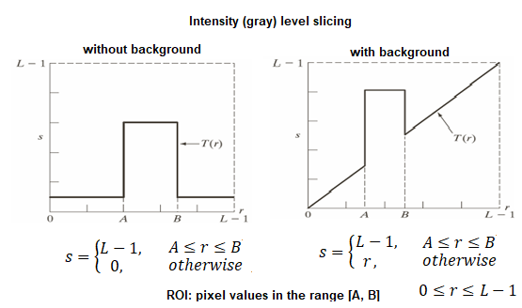

**Figure 3.1**:Gray level slicing

Let us implement gray level slicing and import the required Python libraries and functions to start with.

# %matplotlib inline  
from skimage.io import imread  
from skimage.color import rgb2gray  
import numpy as np  
import matplotlib.pylab as plt  
import warnings  
warnings.filterwarnings('ignore')

The function gray_level_slice() accepts an input grayscale image, along with a minimum and a maximum pixel value as arguments. It applies intensity level slicing with/without background, as described earlier, as specified by the value of the Boolean argument with_background, to be set to True/False, respectively, with the value defaulting to False, as shown in the following code snippet. The function returns the gray level sliced image and the mask created by filtering the pixels outside the pixel range provided as input.

The function plot_images() accepts a list of NumPy arrays as images and the corresponding titles and uses matplotlib.pylab to plot them.

def gray_level_slice(im, min_pixel, max_pixel, with_background=False):  
 im_sliced = im.copy()  
 im_mask = (im >= min_pixel) & (im <= max_pixel)  
 im_sliced[im_mask] = 255  
 ifnot with_background:  
 im_sliced[~im_mask] = 0  
 return im_sliced, im_mask  
  
def plot_images(ims, titles, suptitle = None):  
 n = len(ims)  
 plt.figure(figsize=(15,7))  
 plt.gray()  
 plt.subplots_adjust(0,0,1,0.95,0.05,0.05)  
 for i in range(n):  
 plt.subplot(1,n,i+1), plt.imshow(ims[i]), plt.axis('off')   
 plt.title(titles[i], size=20)  
 if suptitle:  
 plt.suptitle(suptitle, size=25)  
 plt.show()

Now, let us first read the image coins.png.

Use the image gray level histogram to identify the range of grey levels within the coins.

As shown in the following figure, most pixels are between $100$ and $240$:

im = rgb2gray(imread('images/coins.png'))  
im = (255 * im / im.max()).astype(np.uint8)  
  
plt.figure(figsize=(5,3))  
plt.hist(im.flatten(), bins=100), plt.grid()  
plt.title('hisogram of gray levels', size=20)  
plt.show()

If you run the following code snippet, you should obtain a figure as follows:

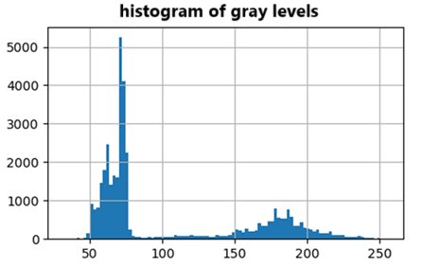

**Figure 3.2**:Bimodal histogram of gray levels

Find all the coins based on pixel range (min_pixel=90 and max_pixel=255), with gray-level slicing, using the function gray_level_slice() implemented earlier, and set pixels inside the coin to white.

For slicing with background set with_background=True specifically, otherwise the rest of the pixels outside the pixel range provided are set to black.

min_pixel, max_pixel = 90, 255  
# to improve use median filter on background to remove light gray pixels  
# initialise your output images  
im_sliced_without_bg, im_mask = gray_level_slice(im, min_pixel, max_pixel)  
im_sliced_with_bg, im_mask = gray_level_slice(im, min_pixel, max_pixel, True)  
  
plot_images([im, im_sliced_without_bg, im_sliced_with_bg],   
 ['original image', 'without background', 'with background'],   
 suptitle = 'gray level slicing with and without background')

If you run the following code snippet, you should obtain a figure as follows:

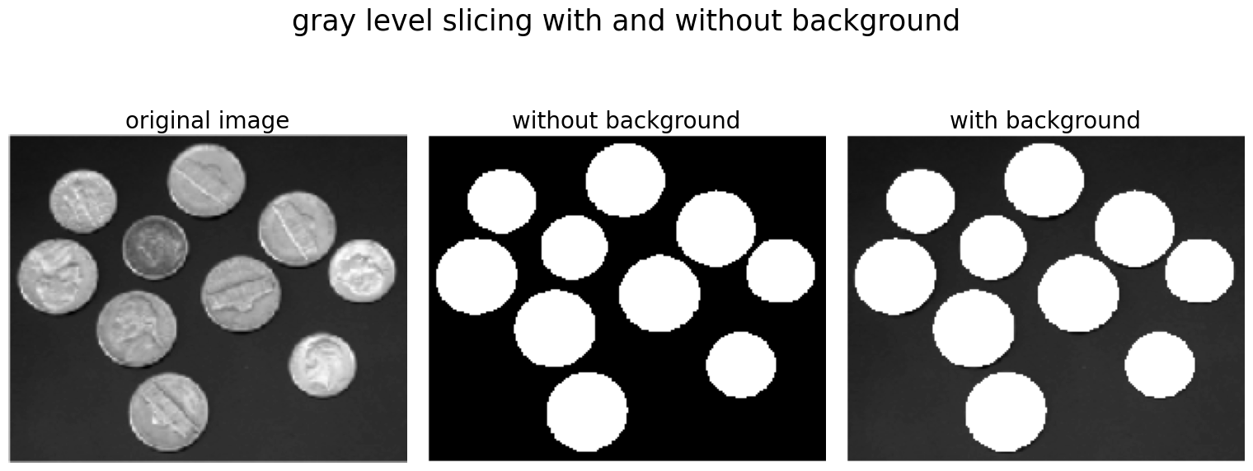

**Figure 3.3**:Gray level slicing

Increasing contrast within ROI

Gray-level slicing is used to emphasize specific regions in an image by isolating the pixel values corresponding to those regions. Let us use the aforementioned implementation on the **region of interest** (**ROI**) of the coin’s image (e.g., the coins) and increase the contrast within the coins using the following code snippet:

The function enhance_image() (defined in the following code snippet) takes the original image along with the ROI mask created (using the gray level slicing) as input and enhances the image only in the ROI. It uses a non-linear transformation on the ROI to improve the contrast of the coins. Finally, it sets the background (outside mask) to another gray level (note that having a single grey level as background may not feel right for human vision).

def enhance_image(im, im_mask, min_pixel):  
 im_enhanced = 0 * im  
 im_enhanced[im_mask] = np.round((im[im_mask] - min_pixel) * 1.8)   
 im_enhanced[~im_mask] = 225 # could be any value or another transform  
 return im_enhanced  
   
im_enhanced = enhance_image(im, im_mask, min_pixel)  
plot_images([im, im_sliced_without_bg, im_enhanced], \  
 ['original image', 'gray level slicing mask', 'image enhanced'])

If you run the aforementioned code snippet, you should obtain a figure as follows:

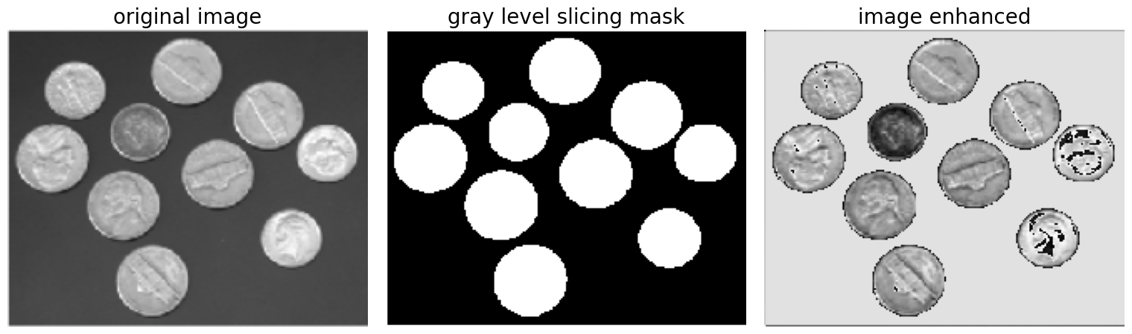

**Figure 3.4**:Increasing contrast within ROI (mask)

Bitplane slicing

In digital image processing, each pixel in an image is represented by a binary number (composed of bits), and bitplane slicing involves extracting the bit values at a specific bit position across all pixels. For an 8-bit image, there are 8 bitplanes (from the **most significant bit** (**MSB**), to the **least significant bit** (**LSB**)), as shown in the following figure. Each bitplane represents a different level of image detail. Instead of highlighting the gray level range, we could highlight the contribution made by each bit. This method is useful and can be used in image compression.

The most significant bits contain the majority of visually significant data. Often, by isolating particular bits of the pixel values in an image, we can highlight interesting aspects of that image. Higher-order bits usually contain most of the significant visual information. Lower-order bits contain subtle details

The following figure shows a schematic diagram for the method:

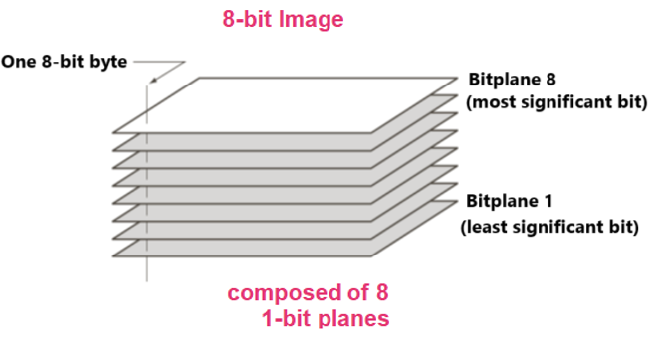

**Figure 3.5**:Bitplane slicing

The following code snippet reads a grayscale image and performs bitplane slicing (extracts the bits from different bitplances using the function np.unpackbits()). As shown in the following code, the higher bitplanes contain the most visual information:

im = (255*rgb2gray(imread('images/Img_03_01.jpg'))).astype(np.uint8)  
h, w = im.shape  
bitplanes = np.unpackbits([im.flatten()], axis=0)  
#bitplanes.shape  
  
plt.figure(figsize=(15,12))  
plt.subplots_adjust(0,0,1,0.95,0.05,0.05)  
plt.gray()  
plt.subplot(3,3,1), plt.imshow(im), plt.axis('off')  
plt.title('original', size=15)  
for i in range(8):  
 plt.subplot(3,3,i+2)  
 plt.imshow(bitplanes[i,:].reshape(h,w)), plt.axis('off')  
 plt.title('bitplane {}'.format(8-i-1))  
plt.show()

If you run the aforementioned code snippet, you should obtain a figure as follows:

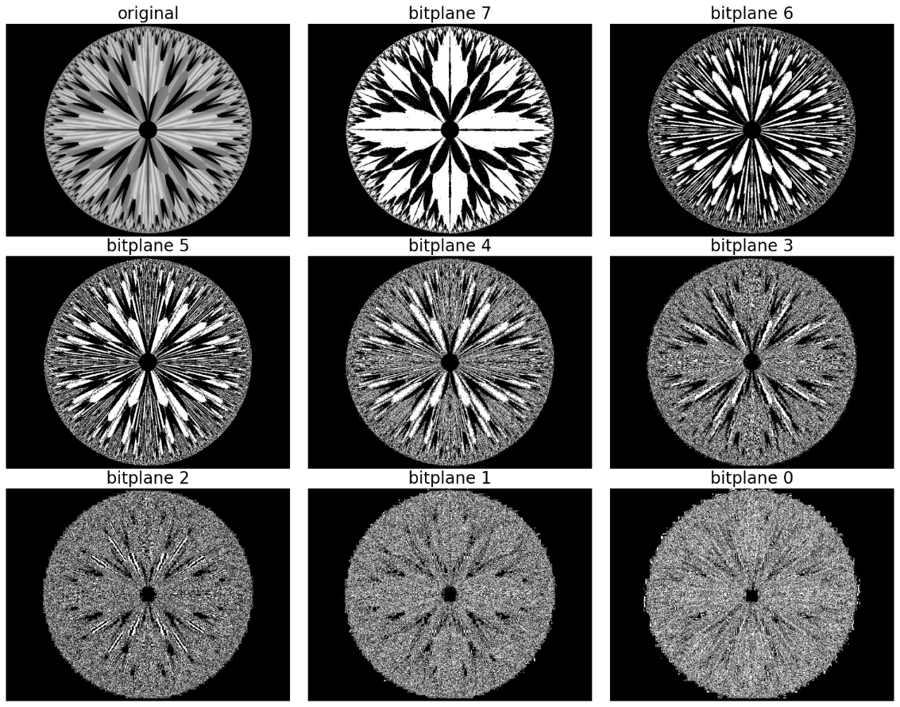

**Figure 3.6**:Original image and the bitplane images

Binarizing an image with thresholding

Image thresholding is a technique used in image processing to separate objects or regions in an image by dividing it into two parts: foreground and background. This separation is based on a threshold value, where pixels with intensities above the threshold are assigned to one class (often known as foreground), and those below the threshold are assigned to another (often called background). The result is a binary image where pixels are either black or white.

Thresholding with scikit-image

The library scikit-image provides a variety of thresholding methods. Here, you will learn how to use different global image thresholding algorithms to binarize an image.

Global thresholding

Global image thresholding involves applying a single threshold value to the entire image. This threshold value is determined based on the characteristics of the entire image, and it is used to separate the image into two regions: one above the threshold and one below the threshold. The result is a binary image with pixels classified into foreground or background.

Let us start the implementation by importing the required libraries, per usual, as shown:

from skimage.io import imread  
from skimage.color import rgb2gray  
import matplotlib.pylab as plt  
from skimage.filters import try_all_threshold, threshold_otsu, rank

The function try_all_threshold() in from skiamge.filters is a useful tool for comparing different global and local thresholding methods. It generates a visual comparison of various thresholding methods, making it easier to choose an appropriate method for a specific image.

The following is an overview of a few global image thresholding algorithms that we shall use:

* **ISODATA**: This **Iterative Self-Organizing Data Analysis** (**ISODATA**) method calculates the threshold as the mean between the average of the pixels below the threshold and the pixels above it. It continues this process until convergence.
* **Mean**: This method calculates the threshold value as the mean intensity of the entire image. Pixels with intensity values above the mean are assigned to one class, while those below are assigned to another.
* **Li/Yen**: These are minimum cross entropy thresholding methods that seek a threshold that minimizes the cross-entropy between the original and binarized images.
* **Minimum**: The histogram of the input image is computed and smoothed until there are only two maxima. The minimum in between is returned as the threshold value.
* **Otsu**: This method finds the (optimal) threshold that minimizes the intra-class variance (or maximizes inter-class variance) of pixel intensities in an image. The algorithm works well for images with bimodal histograms, where there are two distinct intensity peaks corresponding to the foreground and background.

The following are the steps to use the thresholding algorithms:

* Load a sample image and convert it to a grayscale.
* Use the try_all_threshold() function to generate a visual comparison of different global thresholding methods.
* Display the binary images produced using different algorithms, using plt.show(), as the following figure.
* It seems the triangle, and the Yen methods outperform the others for this particular input image.

img = rgb2gray(imread('images/Img_03_02.jpg'))  
img = (255* img / img.max()).astype(np.uint8)  
  
# Here, we specify a radius for local thresholding algorithms.  
# If it is not specified, only global algorithms are called.  
fig, ax = try_all_threshold(img, figsize=(12, 18), verbose=False)  
plt.show()

If you run the aforementioned code snippet, you should obtain a figure as follows:

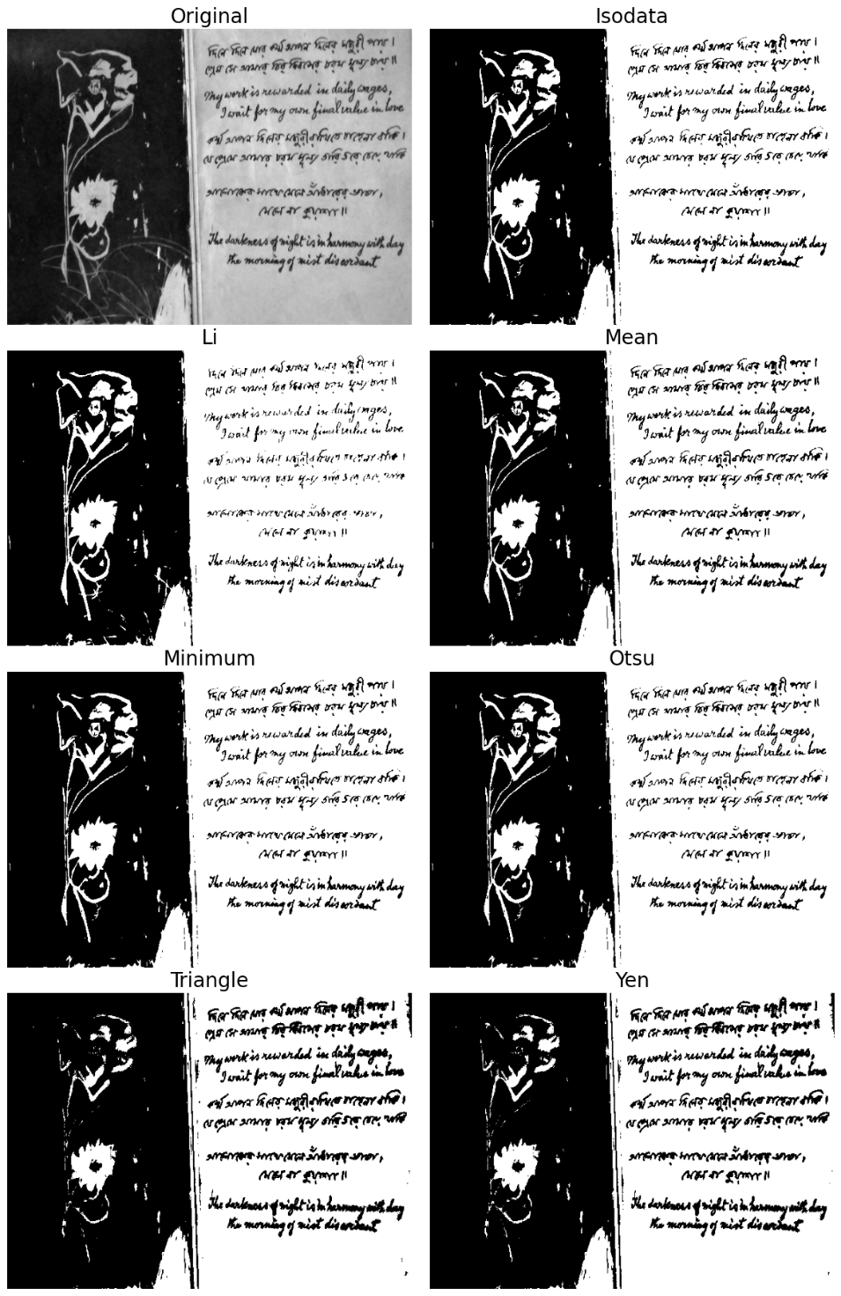

**Figure 3.7**: Binary thresholding with different algorithms

Local thresholding

As discussed earlier, global image thresholding involves applying a single threshold value to the entire image. Local image thresholding, on the other hand, determines different threshold values for different regions of the image. Each pixel’s threshold is computed based on the local characteristics of its neighborhood. This approach is useful when the image exhibits variations in intensity or contrast across different regions.

To simulate local intensity variation, we shall add a small multiplicative (horizontal ramp) noise to the image, using the add_mult_noise() function defined below, using the following code snippet:

from skimage.morphology import disk  
  
def add_mult_noise(img):  
 ramp = np.clip(np.tile(np.linspace(0, 1, img.shape[1]), \  
 (img.shape[0],1)), 0, 255)  
 return (img * ramp).astype(np.uint8)  
  
noisy_img = add_mult_noise(img)

Here we shall discuss how to use the local and the global version of Otsu’s thresholding algorithm to binarize an image.

To obtain the local thresholds, first, create a neighborhood disk of radius=30 (change the radius to see the impact on the binary output image) using the function disk() from skimage.morphology and the function rank.otsu(), along with the input image and neighborhood disk. Use the local thresholds array to obtain the binary image local_otsu.

To obtain a global threshold value using Otsu’s method use filters are used.threshold_otsu() function and use the threshold to obtain the binary image global_otsu.

Finally display the input and output images, notice that local otsu produces a much better binary output image, whereas the one obtained with the global version loses much information.

radius = 30  
footprint = disk(radius)  
local_thresh = rank.otsu(noisy_img, footprint)  
local_otsu = noisy_img > local_thresh  
  
global_thresh = threshold_otsu(noisy_img)  
print(global_thresh)  
# 78  
global_otsu = noisy_img > global_thresh  
  
fig, axes = plt.subplots(nrows=2, ncols=2, figsize=(12, 12))  
ax = axes.ravel()  
ax[0].imshow(noisy_img, cmap=plt.cm.gray, aspect='auto')  
ax[0].set_title('input', size=20), ax[0].axis('off')  
ax[1].imshow(local_otsu, cmap=plt.cm.gray, aspect='auto')  
ax[1].set_title('local Otsu', size=20), ax[1].axis('off')  
ax[2].hist(noisy_img.ravel(), bins=256)  
ax[2].set_title('Histogram', size=20)  
ax[2].axvline(global_thresh, color='r')  
ax[3].imshow(global_otsu, cmap=plt.cm.gray, aspect='auto')  
ax[3].set_title('global Otsu', size=20), ax[3].axis('off')  
plt.tight_layout()  
plt.show()

If you run the aforementioned code snippet, you should obtain a figure as follows:

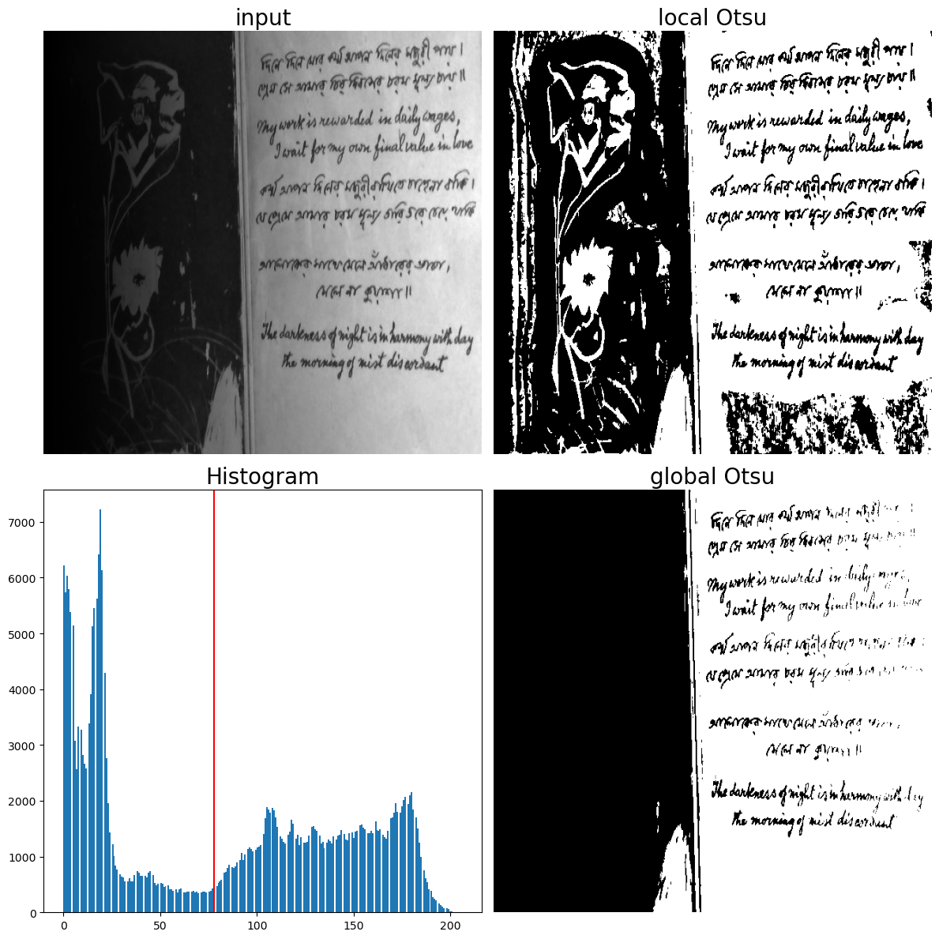

**Figure 3.8**: Optimal thresholding with Otsu’s algorithm (local vs. global)

Max-entropy thresholding with SimpleITK

Now, let us see how we can use the SimpleITK library’s implementation of an entropy-based thresholding algorithm. MaximumEntropyThresholdImageFilter in SimpleITK is an implementation of an automatic thresholding algorithm based on maximum entropy. The goal of the algorithm is to find a threshold that maximizes the entropy of the resulting binary image. Entropy is a measure of uncertainty or disorder, and in the context of image thresholding, it reflects the amount of information carried by the pixel intensity values.

The idea behind using maximum entropy as a criterion is to find a threshold that maximizes the information gained when going from a grayscale image to a binary image. The method tends to work well when the image has a bimodal histogram with distinct foreground and background intensities. The algorithm first computes the normalized intensity histogram for the input image, then computes the **cumulative distribution function** (**CDF**), computes the entropy of the output binary image for each possible threshold, and finds the optimal threshold that maximizes the entropy.

The following code snippet first reads the image with sitk.ReadImage() function scales the intensity values in the range [0,1] using the RescaleIntensityImageFilter() and then applies the MaximumEntropyThresholdImageFilter() to the rescaled image to obtain the output image using the Execute() function. Next, it plots the input and output images, as shown in the following figure:

import SimpleITK as sitk  
  
input_image = sitk.ReadImage('images/Img_03_02.jpg', sitk.sitkFloat32)  
rescale = sitk.RescaleIntensityImageFilter()  
rescale.SetOutputMaximum(1.0)  
input_image = rescale.Execute(input_image)  
  
filter = sitk.MaximumEntropyThresholdImageFilter()  
filter.SetOutsideValue(1)  
filter.SetInsideValue(0)  
output_image = filter.Execute(input_image)  
print(filter.GetThreshold())  
# 0.6269776821136475  
plt.figure(figsize=(20,15))  
plt.gray()  
plt.subplot(121), plt.imshow(sitk.GetArrayFromImage(input_image))  
plt.axis('off'), plt.title('input', size=20)  
plt.subplot(122), plt.imshow(sitk.GetArrayFromImage(output_image))  
plt.axis('off'), plt.title('thresholded', size=20)  
plt.tight_layout()  
plt.show()

If you run the aforementioned code snippet, you should obtain a figure as follows:

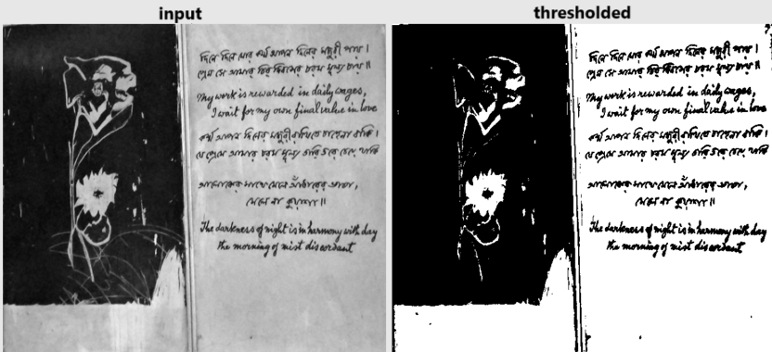

**Figure 3.9**: Grayscale to binary image conversion with max-entropy thresholding

Adaptive thresholding with opencv-python

Adaptive image thresholding is a specific implementation of local image thresholding where the threshold values adapt to local variations in the image. Again, the threshold for each pixel is computed based on the local neighborhood around it.

In this section, we will understand how to use the function cv2.adaptiveThreshold() from opencv-python to perform adaptive thresholding as follows:

* cv2.adaptiveThreshold() function takes an input image, a maxValue (value given to pixels exceeding the threshold), an adaptive method (method used to compute the adaptive threshold, such as cv2.ADAPTIVE_THRESH_GAUSSIAN_C), thresholdType (type of thresholding applied), blockSize (size of the neighborhood area), and C (a constant subtracted from the mean or weighted mean).
* cv2.ADAPTIVE_THRESH_GAUSSIAN_C specifies that the adaptive threshold is computed as the weighted sum of the neighborhood values, where weights are given by a Gaussian window.
* cv2.ADAPTIVE_THRESH_MEAN_C method calculates the threshold for each pixel as the mean of the pixel values in its local neighborhood.
* cv2.THRESH_BINARY specifies that pixels with values above the threshold are set to maxValue (255), and others are set to 0.

Experiment with different values for blockSize and C to see how they affect the adaptive thresholding result based on the characteristics of the input image.

The following code snippet implements adaptive thresholding using the mean and Gaussian adaptive threshold methods and plots the output binary images along with the input image, as shown in the following figure:

import cv2  
import numpy as np  
import matplotlib.pylab as plt  
  
im = cv2.imread('images/Img_03_02.jpg', 0)   
#im = cv2.GaussianBlur(im, (7, 7), 0)  
thresh1 = cv2.adaptiveThreshold(im, 255, cv2.ADAPTIVE_THRESH_MEAN_C,   
 cv2.THRESH_BINARY_INV, 21, 10)  
thresh2 = cv2.adaptiveThreshold(im, 255, cv2.ADAPTIVE_THRESH_GAUSSIAN_C,   
 cv2.THRESH_BINARY_INV, 21, 4)  
  
plt.figure(figsize=(20,12))  
plt.gray()  
plt.subplot(131), plt.imshow(im), plt.axis('off')  
plt.title('input', size=20)  
plt.subplot(132), plt.imshow(thresh1), plt.axis('off')  
plt.title('adaptive thresholded (mean)', size=20)  
plt.subplot(133), plt.imshow(thresh2), plt.axis('off')   
plt.title('adaptive thresholded (gaussian)', size=20)  
plt.tight_layout()  
plt.show()

If you run the aforementioned code snippet, you should obtain a figure as follows:

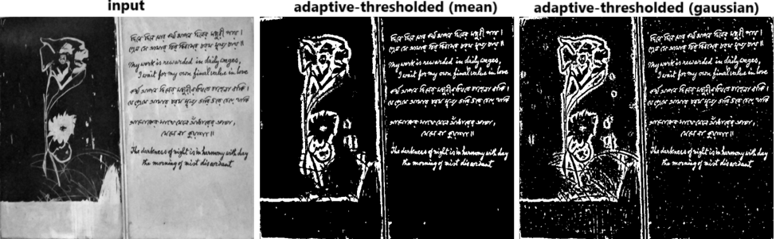

**Figure 3.10**: Adaptive thresholding with opencv-python

Segmentation using clustering

Clustering is an unsupervised technique in machine learning and data analysis where data points are grouped together based on similarity or some inherent structure in the data. The goal of clustering is to partition a dataset into groups, or clusters, such that data points within the same cluster are more similar to each other than to those in other clusters.

Mathematically, clustering can be defined as follows. Let $X=\{x_{1},x_{2},…,x_{n}\}$ be a set of $n$ data points in a feature space. The objective of clustering is to find a partition of $X$ into $K$ clusters $C=\{C_{1},C_{2},…,C_{K}\}$, where each $C_{k}$ represents a cluster.

The partition should satisfy the following criteria:

* **Homogeneity within clusters**: Data points within the same cluster are more similar to each other.
* **Heterogeneity between clusters**: Data points from different clusters are dissimilar.

A common mathematical formulation involves defining an objective function that quantifies the similarity within clusters and dissimilarity between clusters. One such example is the $k$-means clustering algorithm, which aims to minimize the sum of squared distances within clusters:



Here, $μ_{k}$ is the mean of the data points in cluster $C_{k}$.

Now, regarding image segmentation, clustering techniques can be employed to group pixels with similar characteristics into segments. Each pixel is treated as a data point, and the features extracted from the pixels (such as color, intensity, and texture) serve as dimensions in the feature space.

The steps for using clustering for image segmentation might include:

* **Feature extraction**: Extract relevant features from each pixel in the image.
* **Clustering**: Apply a clustering algorithm (e.g., k-means) to group pixels based on their feature vectors.
* **Segmentation**: Assign each pixel to the cluster it belongs to and consider each cluster as a segment in the segmented image.

In this section, you will learn how to:

* Implement image segmentation with clustering using scikit-learn and scipy library functions
* Cluster similar images into groups.

Clustering with Mahalanobis distance

Mahalanobis distance is a measure used to quantify the distance between a point and a distribution. It is a generalized form of the Euclidean distance that takes into account the correlations between different features. This distance metric is particularly useful when dealing with multivariate data where the features are correlated.

The Mahalanobis distance $\left(D_{M}\right)$ between a point $x$ and a distribution with mean $μ$ and covariance matrix $Σ$ is calculated as follows:

$$D_{M}\left(x\right)={\left(x-μ\right)}^{T}Σ^{-1}\left(x-μ\right)$$

In the context of image segmentation, Mahalanobis distance can be applied to cluster pixels based on their feature vectors.

The following is a general outline of how you can use Mahalanobis distance for image segmentation:

* **Feature extraction**: Extract relevant features from each pixel in the image. Here, we shall use RGB colors as features. Hence, the feature space will consist of 3D vectors. Each pixel is represented as a feature vector.
* **Compute mean and covariance**: Compute the mean (*μ*) and covariance matrix (*Σ*) of the feature vectors in the entire image or in predefined regions.
* **Calculate Mahalanobis distance**: For each pixel’s feature vector, calculate its Mahalanobis distance from the mean using the formula mentioned earlier.
* **Segmentation**: Assign pixels to different segments or clusters based on their Mahalanobis distances. Pixels with smaller distances are more likely to belong to the same cluster.
* **Thresholding or clustering**: Apply a threshold or use clustering techniques (e.g., $k$*-*means clustering) to group pixels into distinct segments based on their Mahalanobis distances.

Let us start the implementation by importing the required libraries and modules:

import numpy as np  
import scipy  
from skimage.io import imread  
from skimage.util import crop  
import matplotlib.pylab as plt  
cdist = scipy.spatial.distance.cdist

Now, let us segment the RGB color pepper image into two regions ($K=2$), one containing the red vegetables and the other containing the green vegetables. This is done in the function cluster_rgb_mahalanobis() defined in the following code snippet.

We need to start with two predefined sub-regions by cropping small subsets of pixels from the original image, each one acting as a reference for the corresponding segment.

Use skimage.util.crop() function to crop the reference image patches from the original image by specifying the starting and ending indices along each axis, given by cluster_sample_locs, passed as an argument to the function cluster_rgb_mahalanobis().

The function **cluster_rgb_mahalanobis()**, in turn, uses the function compute_mahalanobis(), which accepts the original image I and the predefined reference image patches S and computes the Mahalanobis distance between each pixel and the predefined patches. For a $m×n$ image, we need to store $\left(mn,2\right)$ distance values (for each of the $mn$ pixels we need to store the Mahalanobis distances to $2$ predefined patches).

The function compute_mahalanobis(), in turn, uses the function mahalanobis() to first compute $μ$, $Σ$ for the reference patches $x$ and then compute the Mahalanobis distance between a pixel RGB vector $y$ and the predefined pixel subsets (clusters).

Assign each pixel to its nearest cluster using the minimum of the Mahalanobis distances computed, as shown in the following code block:

def mahalanobis(y, x):  
 cov_x_inv = np.linalg.inv(np.cov(x,rowvar=False))  
 return cdist(y, np.reshape(np.mean(x, axis=0), (1, -1)),   
 'mahalanobis', VI=cov_x_inv)  
  
def compute_mahalanobis(I, S):   
 R, G, B = I[:,:,0], I[:,:,1], I[:,:,2] #color components  
 subset_R, subset_G, subset_B = S[:,:,0], S[:,:,1], S[:,:,2]  
 x = np.hstack((subset_R.reshape(-1,1), subset_G.reshape(-1,1),   
 subset_B.reshape(-1,1)))  
 y = np.hstack((R.reshape(-1,1), G.reshape(-1,1), B.reshape(-1,1)))  
 return mahalanobis(y, x).ravel()  
  
def cluster_rgb_mahalanobis(im, cluster_sample_locs):   
 mahal_dist = np.zeros((np.prod(im.shape[:2]), \  
 len(cluster_sample_locs)))  
 for i in range(len(cluster_sample_locs)):  
 im_patch = crop(im, cluster_sample_locs[i], copy=False)   
 mahal_dist[:,i] = compute_mahalanobis(im, im_patch)  
 ind = np.argmin(mahal_dist, axis=1)  
 ind = ind.reshape(im.shape[:2])  
 mask = np.zeros(im.shape[:2])  
 for k in range(mahal_dist.shape[1]):  
 mask[ind == k] = k  
 return mask

Now, let us define the locations of the small red and green patches (to be cropped from the original image and used for reference) as cluster_sample_locs.

Read the pepper image.

Use the function cluster_rgb_mahalanobis() defined earlier to segment the image using Mahalanobis distance.

The function cluster_rgb_mahalanobis()accepts the input image along with the predefined reference pixels, as shown in the following code snippet. The function returns the segmentation mask. Display the segmentation mask, along with the original RGB image.

cluster_sample_locs = [  
 ((36, 150), (115, 90), (0,0)),  
 ((127, 70), (143, 60), (0,0))  
 ]  
  
im = imread('images/Img_03_15.png')  
mask = cluster_rgb_mahalanobis(im, cluster_sample_locs)  
  
plt.figure(figsize=(12,6))   
plt.subplots_adjust(0,0,1,0.95,0.05,0.05)  
plt.subplot(121), plt.imshow(im, aspect='auto'), plt.title('RGB IMAGE')  
plt.axis('off')  
plt.subplot(122), plt.imshow(mask, cmap='jet', aspect='auto')  
plt.colorbar(), plt.title('CLUSTERS'), plt.axis('off')  
plt.show()

If you run the aforementioned code snippet, you should obtain a figure as follows:

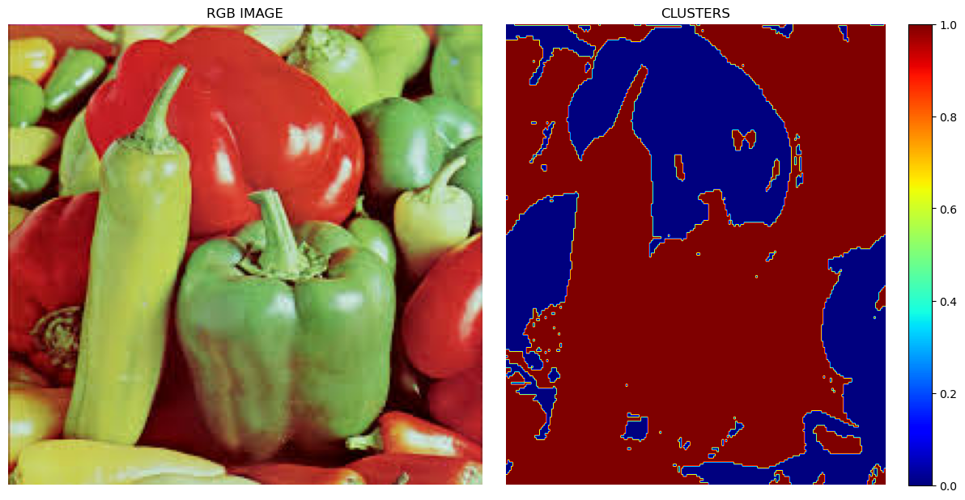

**Figure 3.11**:Clustering with Mahalanobis distance

Now, display the segments separately, as shown in the following figure (left as an exercise to the reader):

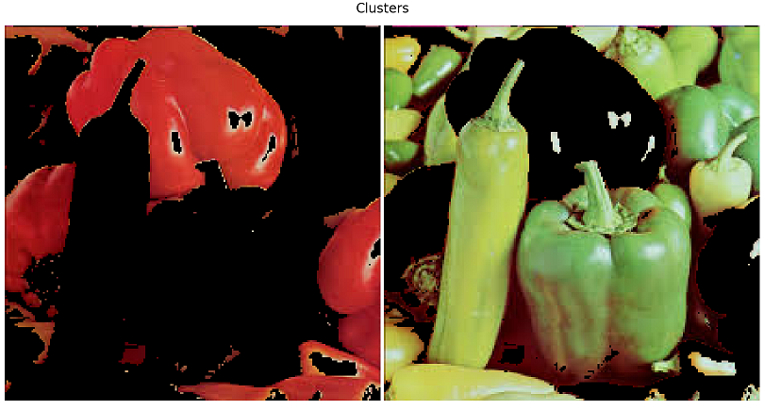

**Figure 3.12**:Two clusters obtained with Mahalanobis distance based clustering

K-means vs. spectral clustering

K-means clustering is a popular unsupervised machine learning algorithm used for partitioning a dataset into K distinct, non-overlapping subsets (clusters). The goal of the k-means algorithm is to assign each data point to one of the K clusters in a way that minimizes the sum of squared distances within each cluster. It is widely used for clustering analysis in various domains, including image processing, data analysis, and machine learning.

The following is a brief overview of how the k-means clustering algorithm works:

* **Initialization**: Choose the number of clusters $K$. Randomly initialize $K$ cluster centroids in the feature space.
* **Assignment**: Assign each data point to the nearest centroid. The assignment is based on the Euclidean distance between the data point and each centroid.
* **Update centroids**: Recalculate the centroids of the clusters as the mean of all data points assigned to each cluster.
* **Repeat**: Repeat steps 2 and 3 until convergence. Convergence occurs when the centroids no longer change significantly or when a predefined number of iterations is reached.

The objective function of k-means is to minimize the sum of squared distances within each cluster. The number of clusters ($K$) needs to be specified in advance, and the algorithm’s performance can be sensitive to this choice.

Performing image segmentation using k-means clustering involves applying the k-means algorithm to group pixels in an image based on their color or intensity values. Each cluster represents a segment in the image.

Here, we shall use the scikit-learn library’s k-means clustering implementation.

Let us start by importing the required libraries as follows:

from sklearn import cluster  
from skimage.io import imread  
from skimage.color import rgb2gray  
from skimage.transform import resize as imresize  
from sklearn.utils import shuffle  
from sklearn.feature_extraction import img_to_graph  
import numpy as np  
import matplotlib.pylab as plt  
import warnings  
warnings.filterwarnings('ignore')

Here is a step-by-step guide to perform segmentation using k-means clustering, as shown in the following code snippet:

1. Load the image using the skimage.io.imread() function, and we shall use three color channels.
2. Reshape the 3D image array into a 2D array of pixels using np.reshape().
3. **Reduce the number of colors**: To improve the algorithm’s performance, randomly sample a subset of pixels (e.g., 1000 pixels) from the image using the function sklearn.utils.shuffle().
4. **Apply k-means clustering**: Use the KMeans class from scikit-learn to perform k-means clustering. Fit the model to the sampled pixels using the function fit().
5. Predict the cluster labels for all pixels in the image using the function predict().
6. **Generate segmented image**: Replace each pixel in the original image with the color of its assigned cluster centroid.

im = imread('images/Img_03_22.png')[...,:3]  
  
X = np.reshape(im, (-1, im.shape[-1]))  
X_sample = shuffle(X, random_state=0)[:1000]  
  
k = 2  
kmeans = cluster.KMeans(n_clusters=k, random_state=10)  
kmeans.fit(X_sample)  
y_pred = kmeans.predict(X).astype(np.uint8)  
labels_kmeans = np.reshape(y_pred, im.shape[:2])

SpectralClustering is a graph-based clustering algorithm that uses the spectral decomposition of the affinity matrix of the data points. It is particularly effective for clustering datasets that exhibit complex structures, including non-convex shapes and clusters of varying shapes and sizes.

The following is an overview of how SpectralClustering works:

* **Affinity matrix**: Given a dataset with $n$ data points, the first step is to construct an affinity matrix $A$, which measures the similarity between data points. Common choices for affinity include the Gaussian (RBF, **Radial Basis Function**) kernel or the nearest neighbor’s graph.
* **Laplacian matrix**: The Laplacian matrix $L$ is computed from the affinity matrix. The Laplacian matrix can be defined as $L=D-A$, where $D$ is the degree matrix, a diagonal matrix where each element $D_{ii}$ is the sum of the elements in the corresponding row of the affinity matrix $A$.
* **Spectral decomposition**: Compute the eigenvectors and eigenvalues of the Laplacian matrix. The $k$ eigenvectors corresponding to the $k$ smallest eigenvalues form the columns of a matrix $X$.
* **Clustering**: Use $X$ as the feature matrix and apply a standard clustering algorithm (e.g., k-means) to cluster the data points in the spectral space.

The key idea behind spectral clustering is that the eigenvectors capture the underlying structure of the data, and clustering in the spectral space can reveal complex structures that may be hard to capture in the original feature space.

To use spectral clustering for image segmentation, you can treat the pixels in the image as data points and apply the spectral clustering algorithm to group them into clusters based on their similarity.

The algorithm is configured to use the nearest neighbors’ graph as the affinity measure (with a number of neighbors = 25) in the following code snippet, which uses SpectralClustering class in sci-kit-learn. The method fit_predict() is used to fit the model and then predict the labels of the pixels in the image.

The image is reduced to a smaller size for faster execution speed as follows:

h, w, _ = im.shape  
#print(h, w)  
im_small = imresize(im, (h//4, w//4))  
X = np.reshape(im_small, (-1, im.shape[-1]))  
spectral = cluster.SpectralClustering(n_clusters=k, eigen_solver='arpack',   
 affinity="nearest_neighbors",   
 n_neighbors=25,   
 assign_labels = 'discretize',  
 random_state=10)  
y_pred = spectral.fit_predict(X).astype(np.uint8)  
labels_spectral = np.reshape(y_pred, im_small.shape[:2])

Visualize the binary segmentation mask and segmented original image side by side for both the clustering algorithms, as shown in the following figure:

plt.figure(figsize=(20,12))  
plt.gray()  
plt.subplots_adjust(0,0,1,0.96,0.05,0.05)  
plt.subplot(221), plt.imshow(labels_kmeans)  
plt.title('k-means segmentation (k=2)', size=30), plt.axis('off')  
plt.subplot(222), plt.imshow(im.copy()), plt.axis('off')  
for l in range(k):  
 plt.contour(labels_kmeans == l, colors='r', linewidths=5)  
plt.title('k-means contour (k=2)', size=30)  
plt.subplot(223), plt.imshow(labels_spectral)  
plt.title('spectral segmentation (k=2)', size=30), plt.axis('off')  
plt.subplot(224), plt.imshow(im_small.copy()), plt.axis('off')  
for l in range(k):  
 plt.contour(labels_spectral == l, colors='r', linewidths=5)  
plt.title('spectral contour (k=2)', size=30)  
plt.show()

If you run the aforementioned code snippet, you should obtain a figure as follows:

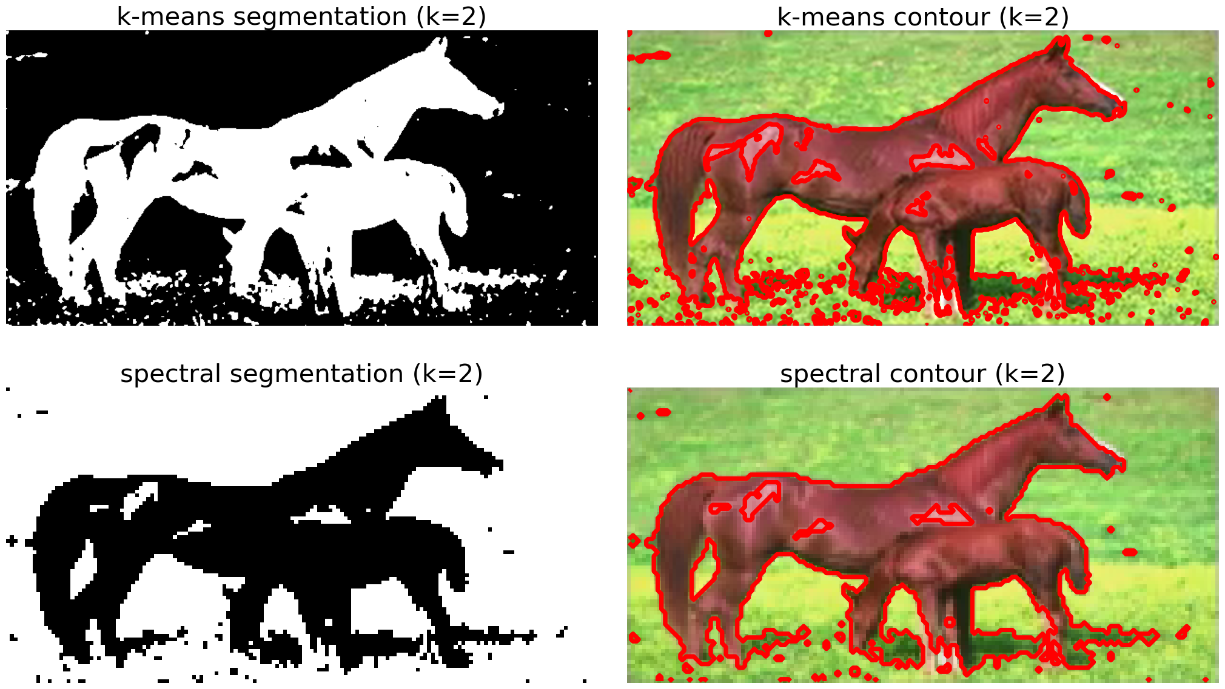

**Figure 3.12**:Image segmentation with k-means vs. spectral clustering

Meanshift segmentation

MeanShift segmentation is a region-based image segmentation that involves grouping similar pixels into regions. The basic idea behind MeanShift is to iteratively shift data points towards the mode (peak) of the data distribution, allowing the points to converge to local maxima. In the context of image segmentation, this means grouping together pixels with similar color or intensity values. This algorithm is used for non-parametric clustering and is particularly effective for situations where the number of clusters is not known beforehand (as opposed to means, where we must specify the number of clusters beforehand). In this section, we will learn how to implement meanshift segmentation with opencv-python and scikit-learn library functions.

MeanShift filtering with opencv-python

As explained earlier, MeanShift algorithm can be applied to group similar pixels into regions, effectively segmenting the image. The algorithm works by iteratively shifting each pixel towards the mean of the pixels within a local spatial and color range until convergence. In opencv-python this algorithm can be implemented using meanshift filtering function cv2.pyrMeanShiftFiltering().

The function cv2.pyrMeanShiftFiltering() operates on an image pyramid. This function is designed to perform more efficient and multi-scale mean shift segmentation by working on different levels or scales of the image.

The function implements the filtering stage of the algorithm, i.e., it outputs a filtered *posterized* image with flattened color gradients and fine-grain texture.

At each pixel $\left(X,Y\right)$ of the input image, the neighborhood of the pixel in the joint space-color (*sp*, *sr*) hyperspace is considered:

$$\left(x,y\right):X-sp≤x≤X+sp, Y-sp≤y≤Y+sp, ∥\left(R,G,B\right)-\left(r,g,b\right)∥≤sr$$

Where (*R,G,B*) and (*r,g,b*) are color component vectors (*X,Y*) and (*x,y*), respectively. The average spatial value $\left(X',Y'\right)$ and average color vector $\left(R',G',B'\right)$ are computed over the nbd and they will be the neighborhood centers on the next iteration.

When the algorithm converges, the color components of the initial pixel are set to the final value (average color at the last iteration):

$$I\left(X,Y\right)←\left(R^{*},G^{*},B^{*}\right)$$

The function cv2.pyrMeanShiftFiltering() accepts the following parameters as input:

* src: The source image.
* sp: The spatial window radius (the spatial neighborhood).
* sr: The color window radius (the color neighborhood).
* maxLevel: The maximum level of the image pyramid for the segmentation. It determines how many levels of the pyramid will be used. Higher levels represent lower resolutions of the image. This is an optional parameter with default value $=1$. When maxLevel $>0$, the Gaussian pyramid of maxLevel $+1$ levels is built, and the aforementioned procedure is run on the smallest layer first. Next, the results are propagated to the larger layer, and the iterations are run again only on those pixels for which the layer colors differ by more than sr from the lower-resolution layer of the pyramid. It helps creating color sharper regions boundaries.
* **termcrit**: Termination criteria for the iterative procedure, an optional parameter, often specified as a tuple (epsilon, max_iterations), indicating the desired accuracy and the maximum number of iterations, respectively.

The function cv2.meanShift() is often confused with the aforementioned function, but it is not specifically designed for image segmentation using the traditional MeanShift segmentation algorithm. Instead, it is often used for object tracking.

Let us demonstrate how the function cv2.pyrMeanShiftFiltering() can be used for image segmentation using the following code snippet. As usual, let us start by importing the required libraries, along with opencv-python (cv2).

Load an image of flowers and perform pyramid mean shift filtering with cv2.pyrMeanShiftFiltering(), using sp=20 and sr=50.

import cv2  
import numpy as np  
import matplotlib.pylab as plt  
  
image = cv2.imread('images/Img_03_03.jpg')  
original = np.copy(image)  
shifted = cv2.pyrMeanShiftFiltering(image, 20, 50)

Convert the mean shift image to grayscale, then apply Otsu’s thresholding with the function cv2.threshold().

Find contours in the thresholded image using the function cv2.findContours(), loop over the contours, and draw the contours using the following code snippet:

gray = cv2.cvtColor(shifted, cv2.COLOR_BGR2GRAY)  
thresh = np.invert(cv2.threshold(gray, 0, 255, cv2.THRESH_BINARY | \  
 cv2.THRESH_OTSU)[1])  
cnts, _ = cv2.findContours(thresh.copy(), cv2.RETR_EXTERNAL, \  
 cv2.CHAIN_APPROX_SIMPLE)  
print("{} unique contours found".format(len(cnts)))  
# 2 unique contours found  
   
for (i, c) in enumerate(cnts):  
 ((x, y), _) = cv2.minEnclosingCircle(c)  
 cv2.putText(image, "#{}".format(i + 1), (int(x) - 10, int(y)), \  
 cv2.FONT_HERSHEY_SIMPLEX, 0.6, (0, 0, 255), 2)  
 cv2.drawContours(image, [c], -1, (0, 255, 0), 2)

Plot the original image, mean shift segmentation output, the binary mask obtained, and the contours overlayed on the original image, side-by-side, using the following code snippet:

plt.figure(figsize=(20,15))  
plt.subplot(221), plt.imshow(cv2.cvtColor(original, cv2.COLOR_BGR2RGB))   
plt.axis('off'), plt.title('Original image', size=20)  
plt.subplot(222), plt.imshow(cv2.cvtColor(shifted, cv2.COLOR_BGR2RGB))   
plt.axis('off'), plt.title('With MeanShift', size=20)  
plt.subplot(223), plt.imshow(thresh, cmap='gray'), plt.axis('off')   
plt.title('With MeanShift + Otsu', size=20)  
plt.subplot(224), plt.imshow(image), plt.axis('off')   
plt.title('With Contours', size=20)  
plt.show()

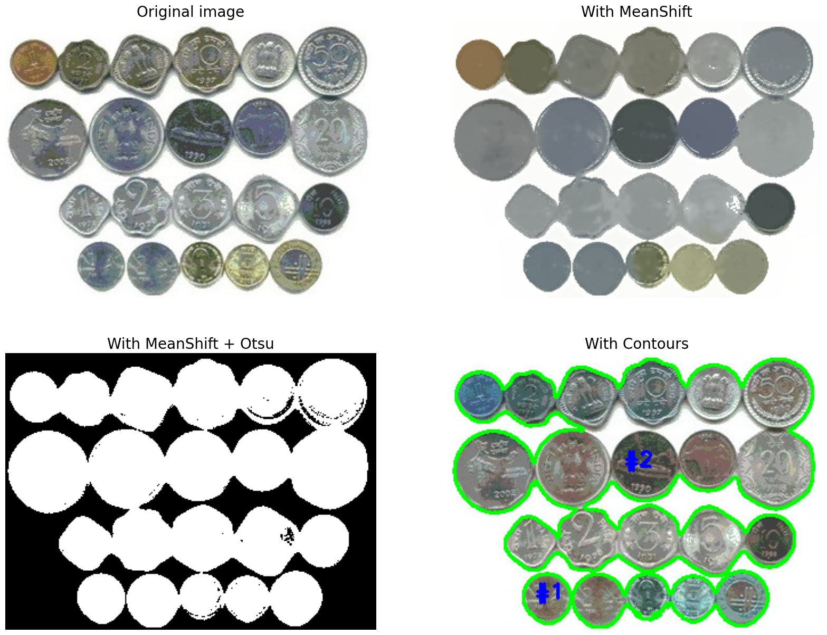

**Figure 3.13**:Meanshift filtering with opencv-python

Segmentation with Mean-shift clustering in lab space with scikit-learn

Let us now demonstrate how the meanshift segmentation can be implemented using scikit-learn.cluster module’s implementation of meanshift clustering. Last time, we used RGB color space but this time, we shall work on the **LAB** color space (L: Lightness, A: Green-Red, and B: Blue-Yellow channel) for the input image.

The following are the steps to be followed.

1. Load the input image and flatten it, so that $m×n×3$ image becomes $mn×3$ ndarray.
2. Use the function sklearn.cluster.estimate_bandwidth() to estimate the bandwidth parameter for MeanShift clustering. The bandwidth is a crucial parameter in the MeanShift algorithm as it determines the size of the region for which points are considered similar during the mean shift process. The quantile parameter controls the proportion of data points to use for the kernel density estimate. It represents the fraction of samples to include in the kernel density estimation (the default value is 0.3, meaning that the bandwidth will be chosen to include 30% of the samples), whereas the n_samples parameter indicates the number of samples to use for the estimation (if None, all samples are used)
3. Given the estimated bandwidth, the MeanShift algorithm is applied (using the function sklearn.cluster.MeanShift()) to cluster the data points (pixels). For each data point, a mean shift vector is computed, pointing towards the mode of the data distribution within the specified bandwidth. The point is then shifted in the direction of this vector, as shown in the following code snippet.
4. The process of computing mean shift vectors and shifting points is repeated until convergence. Convergence occurs when the mean shift vectors become very small or when the maximum number of iterations is reached.
5. After convergence, the algorithm assigns each data point to the cluster to which it converged. Points that converge to the same mode are considered part of the same cluster.
6. Finally, plot the original and the segmented image, along with the scatterplot along the a-b color axes for the Lab color space, to visualize how the meanshift algorithm groups the pixels of the same colors together, as shown in the following code snippet:

import numpy as np  
from sklearn.cluster import MeanShift, estimate_bandwidth  
import matplotlib.pyplot as plt  
from skimage.io import imread  
from skimage.color import rgb2lab, label2rgb  
  
image = imread('images/Img_03_04.jpg')   
flattened_image = np.reshape(rgb2lab(image), [-1, 3])  
   
# estimate bandwidth  
bandwidth = estimate_bandwidth(flattened_image[:, 1:], quantile=.2,   
 n_samples=5000)  
ms = MeanShift(bandwidth=bandwidth, bin_seeding=True)  
ms.fit(flattened_image)  
labels = ms.labels_  
print(len(np.unique(labels)))  
# 7  
  
labels2 = np.reshape(labels, image.shape[:2])  
plt.figure(figsize=(15,15))  
plt.subplot(221), plt.imshow(image), plt.axis('off')  
plt.title('original image', size=20)  
plt.subplot(222)  
plt.scatter(flattened_image[:,1],flattened_image[:,2],   
 color=np.reshape(image, [-1, 3])/255)  
plt.xlabel('a'), plt.ylabel('b'), plt.grid()  
plt.title('scattering with a-b', size=20)  
plt.subplot(223)  
plt.scatter(flattened_image[:,1],flattened_image[:,2],   
 color=np.reshape(label2rgb(labels2, image, kind='avg'),   
 [-1,3])/255, cmap='jet')  
plt.xlabel('a'), plt.ylabel('b'), plt.grid()  
plt.title('segmenting with a-b', size=20)  
plt.subplot(224), plt.imshow(label2rgb(labels2, image, kind='avg'))   
plt.axis('off'), plt.title('segmented image with Meanshift', size=20)  
plt.show()

If you run the aforementioned code snippet, you should obtain a figure as follows:

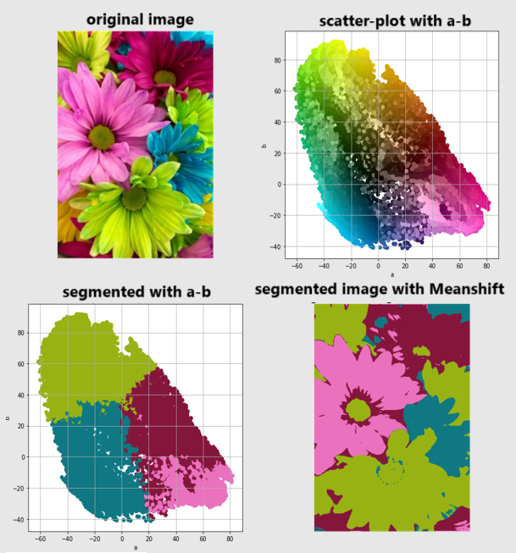

**Figure 3.14**:Meanshift segmentation in Lab color space with scikit-learn

Watershed segmentation

Watershed segmentation is a digital image processing technique used for segmentation, which is the process of dividing an image into different regions or segments. The watershed algorithm is primarily considered a region-based segmentation algorithm. The term **watershed** is borrowed from hydrology, where it refers to the boundary line separating two adjacent drainage basins. In image processing, the concept is applied to separate different objects or regions based on the topological features of the image.

The following is a simplified explanation of how watershed segmentation works:

* **Gradient computation**: The first step involves computing the gradient of the image. The gradient represents the intensity change in the image, highlighting regions where the intensity varies significantly.
* **Intensity marking**: Local minima in the gradient image are identified as markers. These markers serve as seeds for the segmentation process. Each marker is associated with a specific region in the image.
* **Label propagation**: Starting from the markers, labels are propagated outward to neighboring pixels. The goal is to flood the image with labels, simulating the filling of basins in a topographical map.
* **Catchment basins**: As the labels propagate, they eventually meet at certain points, forming boundaries between different catchment basins. These boundaries correspond to the desired segmentation.
* **Segmentation result**: The final result of watershed segmentation is a partitioning of the image into regions separated by the boundaries identified in the process.

Watershed segmentation can be applied to grayscale or color images. It is particularly useful in scenarios where objects in an image have poorly defined boundaries or when there are significant intensity variations. However, watershed segmentation can lead to over-segmentation, where small details are treated as separate regions. To address this, techniques such as marker-controlled watershed segmentation are used, allowing users to guide the segmentation process by specifying markers for certain regions of interest.

In this section you will learn to segment an image with watershed segmentation algorithm, using libraries such as opencv-python and SimpleITK.

Watershed with opencv-python

You can perform watershed segmentation using the cv2.watershed() function from the library opencv-python. Here we shall use the algorithm to separate the foreground object from the background in a coins image (i.e., for binary segmentation). Let us start the implementation by importing the required libraries and functions.

import cv2  
import numpy as np  
import matplotlib.pyplot as plt

Let us implement the function run_watershed() as shown in the following code snippet. The function accepts the input image (to be segmented) as the input argument and performs the following operations step by step:

1. Convert the input image from BGR to grayscale using the function cv2.cvtColor() with the flag cv2.COLOR_BGR2GRAY.
2. Apply thresholding with cv2.threshold() (using Otsu’s method cv2.THRESH_OTSU) to create a binary image. Perform morphological opening with cv2.morphologyEx() and cv2.MORPH_OPEN (using a $3×3$ square structural element) to remove noise and small objects.
3. Dilate (using the function cv2.dilate()) the opening to obtain a sure background. Calculate the distance transform (with the function cv2.distanceTransform()) to find the sure foreground by thresholding. The function cv2.distanceTransform() is used to compute the distance transform of a binary image. The distance transform calculates the distance from each pixel to the nearest zero (background) pixel. This function is particularly useful for finding the distance to the closest boundary or object in a binary image.
4. Convert the sure foreground to an 8-bit image and find the unknown region by subtracting (using cv2.subtract()) the sure foreground from the sure background.
5. Label the sure foreground regions using connected components (using cv2.connectedComponents() function). Add 1 to all labels and mark the unknown regions with 0.
6. Apply the watershed algorithm using the markers, using the function cv2.watershed(), as demonstrated in the following code snippet.
7. Mark the watershed boundaries in green and use the function cv2.findContours() to find contours in the binary masks obtained through thresholding. The contours are then drawn on the original image using cv2.drawContours(). Note that here we are interested to draw the innermost contours, hence we have used the hierarchy information (using mode = cv2.RETR_TREE) obtained from cv2.findContours(), hence we have looped through the contours and considered only those contours whose hierarchy[contour_index][3] (parent) is not -1.

The function run_watershed() returns the dist_transform, the markers and the final image with the contours drawn on top, as demonstrated in the following code snippet. Finally, load the input coins image and segment it with watershed algorithm using the function runwatershed().

def run_watershed(image):  
   
 gray = cv2.cvtColor(image, cv2.COLOR_BGR2GRAY)  
 # threshold to obtain binary image  
 ret, thresh = cv2.threshold(gray,0,255,cv2.THRESH_BINARY_INV + \  
 cv2.THRESH_OTSU)  
 # noise removal  
 kernel = np.ones((3,3),np.uint8)  
 opening = cv2.morphologyEx(thresh,cv2.MORPH_OPEN,kernel, iterations = 1)  
 # sure background area  
 sure_bg = cv2.dilate(opening,kernel,iterations=3)  
 # Finding sure foreground area  
 dist_transform = cv2.distanceTransform(opening, cv2.DIST_L2, 5)  
 ret, sure_fg = cv2.threshold(dist_transform,0.0001*dist_transform.max(),\  
 255,0)  
 # Finding unknown region  
 sure_fg = np.uint8(sure_fg)  
 unknown = cv2.subtract(sure_bg,sure_fg)  
  
 # Marker labelling  
 ret, markers = cv2.connectedComponents(sure_fg)  
 # Add one to all labels so that sure background is not 0, but 1  
 markers = markers+1  
 # Now, mark the region of unknown with zero  
 markers[unknown==255] = 0  
  
 markers = cv2.watershed(image,markers)  
 image[markers == -1] = [255,0,0]  
  
 # loop over the unique labels returned by the Watershed algorithm  
 for label in np.unique(markers):  
 # if the label is zero, it’s 'background', so simply ignore it  
 if label == 0:  
 continue  
  
 # otherwise, allocate memory for label region and draw it on the mask  
 mask = np.zeros(gray.shape, dtype="uint8")  
 mask[markers == label] = 255  
  
 # detect contours in the mask and grab the largest one  
 contours, hierarchy = cv2.findContours(mask.copy(), cv2.RETR_TREE, \  
 cv2.CHAIN_APPROX_SIMPLE)  
 for i in range(len(contours)):  
 # Check if the contour has a parent (not the outermost contour)  
 if hierarchy[0][i][3] != -1:  
 color = (0, 255, 0) # Green color  
 cv2.drawContours(image, contours, i, color, 2, cv2.LINE_8, \   
 hierarchy, 0)   
   
 return dist_transform, markers, image  
   
# Load the image  
image = cv2.imread('images/Img_03_03.jpg')  
original = image.copy()  
dist_transform, markers, image = run_watershed(image)

Plot the input coins image along with the segmented image and draw the contours of the objects with matplotlib.pylab, you should obtain a figure like the following one:

plt.figure(figsize=(12,8))  
plt.subplot(221), plt.imshow(cv2.cvtColor(original, cv2.COLOR_BGR2RGB))  
plt.axis('off'), plt.title('Original image', size=20)  
plt.subplot(222), plt.imshow(dist_transform, cmap='Spectral') plt.axis('off')plt.title('Distance', size=20)  
plt.subplot(223), plt.imshow(markers, cmap='coolwarm'), plt.axis('off')  
plt.title('Segmentation Labels', size=20)  
plt.subplot(224), plt.imshow(image), plt.axis('off')  
plt.title('With Contours', size=20)  
plt.tight_layout()  
plt.show()

If you run the aforementioned code snippet, you should obtain a figure as follows:

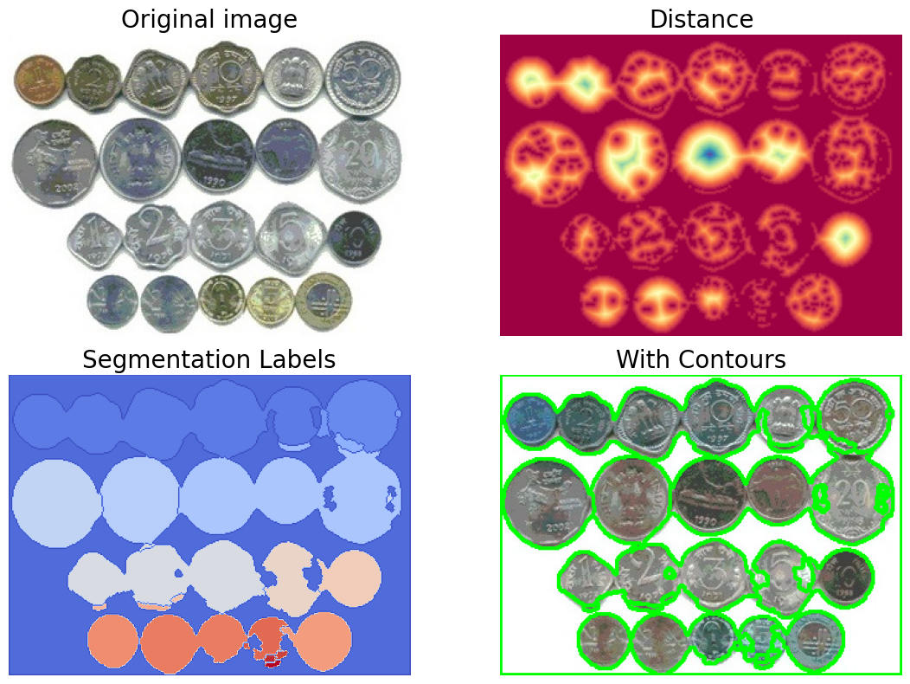

**Figure 3.15**: Watershed segmentation with opencv-python

Morphological watershed with SimpleITK

The morphological watershed algorithm is an extension or modification of the basic watershed algorithm. It often involves combining morphological operations with the watershed algorithm to improve segmentation results (in the last section, we used a few morphological operations explicitly and separately as preprocessing steps for watershed segmentation). It is again based on the concept of flooding and watershed lines, like how water flows in terrain and collects in basins. In image processing, the grayscale intensity values are considered as terrain, and the watershed algorithm is applied to segment different regions based on intensity.

Now, let us see how you can implement morphological watershed segmentation using SimpleITK in Python:

* Import the SimpleITK library and aliased it as sitk for convenience, along with other required libraries.
* Read the input image of a whale as a grayscale image, we shall again perform a binary segmentation on this image, but this time using SimpleITK’s watershed implementation.
* Rescale the intensity values of the input image using RescaleIntensityImageFilter(), apply this filter to normalize or adjust range of pixel intensities of the input image, to be in the range $\left[0,1\right]$, as shown in the following code snippet:

import SimpleITK as sitk  
import numpy as np  
import matplotlib.pylab as plt  
  
img = sitk.ReadImage('images/Img_03_05.jpg', sitk.sitkFloat64)  
rescale = sitk.RescaleIntensityImageFilter()  
rescale.SetOutputMaximum(1.0)  
img = rescale.Execute(img)

* Compute the gradient magnitude of the input image as feature_img, using the function GradientMagnitude(). The gradient magnitude highlights regions where intensity changes.
* Generate markers based on the gradient magnitude. In this example, connected components are identified where the gradient magnitude is greater than the mean value.
* Use regional minima (with RegionalMinima()) as markers in subsequent watershed segmentation to define the initial flooding points.
* Use the function ConnectedComponent() to identify and label individual regions to the detected regional minima.
* We shall use 3 additional points as hints (plotted as magenta pixels on top the input image), a couple of them belong to background and the remaining one on the foreground object, let us specify the labels of the corresponding pixels in the marker image (with values 1 and 2, respectively), as shown in the following code snippet.
* Apply morphological watershed segmentation using the gradient magnitude and markers, using the function MorphologicalWatershedFromMarkers(), which accepts the gradient and the marker images as input.
* Use the function LabelToRGB() to obtain the segmentation binary mask image.
* Overlay the mask on top of the input image using the function LabelOverlay() with a given opacity.

feature_img = sitk.GradientMagnitude(img)  
min_img = sitk.RegionalMinima(feature_img, backgroundValue=0,   
 foregroundValue=1.0, fullyConnected=False,   
 flatIsMinima=True)  
marker_img = sitk.ConnectedComponent(min_img)  
marker_img *= 0  
marker_pts = {(10,10):1, (350,200):2, (500,300):1}  
for pt, label in marker_pts.items():  
 marker_img[pt] = label  
ws = sitk.MorphologicalWatershedFromMarkers(feature_img, marker_img,   
 markWatershedLine=True, fullyConnected=False)  
labels = sitk.LabelToRGB(ws)  
overlay = sitk.LabelOverlay(img, ws, opacity=0.001)  
labels = rescale.Execute(labels)  
overlay = rescale.Execute(overlay)

* Plot the images obtained. The following figure shows the output segmented image, along with the input image.

plt.figure(figsize=(20,10))  
plt.subplot(131), plt.imshow(sitk.GetArrayFromImage(img), cmap='gray')   
plt.axis('off')  
for pt, label in marker_pts.items():  
 plt.scatter(pt[0], pt[1], c=label, s=100, cmap='Spectral')  
plt.title('input (with markers)', size=20)  
plt.subplot(132), plt.imshow(255*sitk.GetArrayFromImage(labels))   
plt.axis('off'), plt.title('segmented', size=20)  
plt.subplot(133), plt.imshow(sitk.GetArrayFromImage(overlay))  
plt.axis('off'), plt.title('overlayed', size=20)  
plt.tight_layout()  
plt.show()

If you run the aforementioned code snippet, you should obtain a figure as follows:

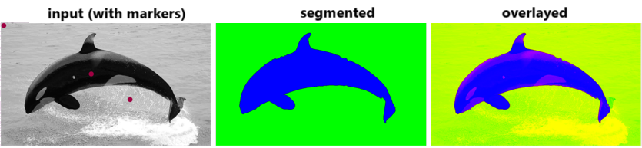

**Figure 3.16**: Morphological watershed segmentation with SimpleITK

GrabCut interactive segmentation with opencv-python

GrabCut is an image segmentation algorithm that that combines image clustering and graph cuts to achieve image segmentation. It is designed to automatically segment an image into foreground and background regions. GrabCut is an improvement over basic graph cut segmentation, as it combines both data-driven and user-provided information to achieve better segmentation results.

The following is a brief overview of the mentioned segmentation techniques:

* **Graph cut segmentation**: Basic graph cut segmentation is an optimization technique that formulates image segmentation as an energy minimization problem. It constructs a graph where pixels are nodes, and edges represent the relationships between neighboring pixels. The goal is to find a cut in the graph that minimizes the energy, separating the image into segments. The energy function typically consists of two main terms: the data term and the smoothness term.
* The data term measures the cost or likelihood of assigning a particular label (foreground or background) to each pixel in the image. Mathematically, the data term can be represented as:


* Here, $X_{i}$ is the label assigned to pixel $i$, and $D_{i}\left(X_{i}\right)$ is the data cost associated with assigning label $X_{i}$ to pixel $i$.
* The smoothness term (pairwise term) encourages neighboring pixels to have similar labels, promoting spatial coherence in the segmentation. It penalizes abrupt changes in labels between neighboring pixels. This term helps to smooth out the segmentation boundaries. Mathematically, the smoothness term can be represented as:


* Here, $S_{ij}\left(X_{i},X_{j}\right)$ is the smoothness cost associated with the labels of neighboring pixels $i$ and $j$.
* The overall energy function for the image segmentation problem with graph cuts is a combination of the data term and the smoothness term:
$$E\left(X\right)=D\left(X\right)+λS\left(X\right)$$

* Here $λ$ is a parameter that controls the trade-off between the data and smoothness terms. The goal of the optimization process is to find the labeling $X$ that minimizes this energy function. Graph cut algorithms, such as the max-flow min-cut algorithm, are then applied to efficiently find the optimal partition or labeling that minimizes the energy.
* **GrabCut segmentation**: GrabCut is an interactive segmentation algorithm that combines user input with an iterative optimization process. The user provides a bounding box around the object of interest, and GrabCut iteratively refines the segmentation based on user input and image data. It employs a graphical model with a graph structure to represent the relationships between pixels and incorporates user scribbles to guide the segmentation.
* **Gaussian mixture model** (**GMM**) is used to model the foreground and background. Depending on the input scribbles (hints), GMM learns and create new pixel distribution.
* A graph is built from this pixel distribution. Nodes in the graphs are pixels. Additional two nodes are added, source node and sink node. Every foreground pixel is connected to source node and every background pixel is connected to sink node.
* The weights of edges connecting pixels to source node/end node are defined by the probability of a pixel being foreground/background. The weights between the pixels are defined by the edge information or pixel similarity. If there is a large difference in pixel color, the edge between them will get a low weight.
* Then a **Min-Cut** (**Minimum Cut**) algorithm is used to segment the graph. It cuts the graph into two separating source node and sink node with minimum cost function. The cost function is the sum of all weights of the edges that are cut. After the cut, all the pixels connected to source node become the foreground and those connected to the sink node become the background.

In this example, we first need to provide the image to segment (we shall use the image of the flower from the Berkely segmentation dataset) and a rectangle around the object of interest (rect). The GrabCut algorithm will then iteratively refine the segmentation based on this user input. The resulting segmented image is displayed using matplotlib.pylab.

Here, you will understand how to use cv2.grabCut() function to implement binary segmentation using the algorithm. The function in opencv-python has several arguments that control the behavior of the GrabCut algorithm. Here is an overview of the main arguments:

* img: Input image (to be segmented).
* mask: A mask image used to initialize and store the segmentation. It should be a 2D array with the same height and width as the input image. The mask is typically initialized with zeros, and the user provides seed points (rectangles or points) to indicate the initial estimate of the foreground and background.
* rect: A rectangle, a tuple specifying the rectangle that encloses the object of interest. The tuple format is (x, y, width, height). This rectangle is used as an initial estimate for the foreground.
* bgdModel **and** fgModel: Background and foreground model. These are arrays used by the algorithm internally; they are updated by the function during the iterative optimization process.
* iterCount: The number of iterations the GrabCut algorithm will run to refine the segmentation. A larger number of iterations may lead to a more accurate segmentation (set to $5$ in the following code snippet).
* mode: An optional parameter that specifies the operation mode. It can take one of the following values:
* cv2.GC_INIT_WITH_RECT: The rectangle provided in rect is used as the initial segmentation.
* cv2.GC_INIT_WITH_MASK: The mask provided in the mask is used as the initial segmentation.
* If None, the function starts with an internally computed segmentation (may not be accurate).

import numpy as np  
import cv2  
from matplotlib import pyplot as plt  
  
orig = cv2.imread('images/Img_03_06.png')  
img = np.copy(orig)  
mask = np.zeros(img.shape[:2],np.uint8)  
  
# specify rectangle around object of interest (x, y, width, height)  
rect = (25,20,400,280)  
cv2.grabCut(img, mask, rect, None, None, 5, cv2.GC_INIT_WITH_RECT)  
  
# Modify the mask to get the binary segmentation result  
mask = np.where((mask==2)|(mask==0),0,1).astype('uint8')  
# Apply the mask to the original image  
img = img * mask[:,:,np.newaxis]  
  
fig, (ax1, ax2) = plt.subplots(1, 2, figsize=(12, 7), \  
 sharex=True, sharey=True)  
cv2.rectangle(orig, (rect[0], rect[1]), (rect[2], rect[3]), (255,0,0), 2)  
ax1.imshow(cv2.cvtColor(orig, cv2.COLOR_BGR2RGB)), ax1.axis('off')  
ax1.set_title('Original Image (with Object hint rectangle)', size=15)  
ax2.imshow(cv2.cvtColor(img, cv2.COLOR_BGR2RGB)), ax2.axis('off')  
ax2.set_title('Segmented Object with GrabCut', size=15) #,plt.colorbar()  
plt.tight_layout()  
plt.show()

If you run the aforementioned code snippet, you should obtain a figure as follows:

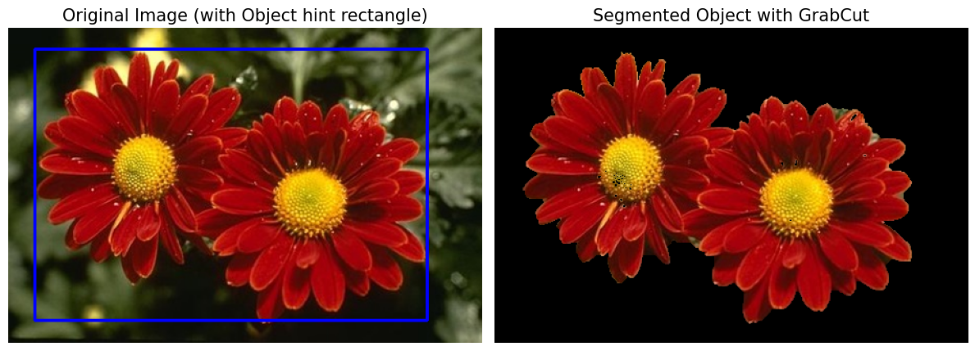

**Figure 3.17**: Interactive GrabCut segmentation with opencv-python

RandomWalk segmentation with scikit-image

Random walk image segmentation is a technique used for partitioning an image into different regions based on the concept of a random walk on a graph. In this method, each pixel in the image is treated as a node in a graph, and the intensity values or features of the pixels determine the weights of the edges between the nodes. The random walk algorithm then simulates a random walker moving on the graph, and the segmentation is obtained based on the probabilities of the walker reaching different regions.

In this problem, you will learn how to use scikit-image’s implementation of the random walker segmentation algorithm. Let us start by importing the required Python libraries, modules and functions.

from skimage.segmentation import random_walker  
from skimage.io import imread  
import numpy as np  
import matplotlib.pyplot as plt  
from mpl_toolkits.axes_grid1 import make_axes_locatable

The random_walker function in scikit-image is part of the skimage.segmentation module. We shall use this function for random walker image segmentation. Here is an overview of how the function works and its key arguments:

* **data**: The input image (a 2D grayscale or a 3D multichannel image) to be segmented.
* **markers**: An array of the same shape as data where markers indicate the segmentation regions. It should be an array of integers, where different integers represent different regions. Typically, you would set certain pixels as markers (e.g., background and foreground markers) to guide the segmentation.
* **beta**: A parameter that controls the influence of the smoothness term. Higher values of beta result in smoother segmentations. Adjust this parameter based on the characteristics of your images.
* **mode**: Specifies the update rule, default is ‘bf’ (backward/forward) and often more stable.
* **channel_axis**: Specifies the channel axis for a multichannel image, i.e., $-1$ indicates that the last dimension is the channel dimension.

The following is the input image is a white horse image, and we aim to segment the image from the background.

* We shall use the annotated (scribbled) horse image (red and green scribbles denote the background and foreground regions, respectively) to create the marker image, first creating blank marker image and then marking the corresponding pixels by different integers (e.g., $1$ and $2$) as shown in the following code snippet.
* Use the random_walker() function to get the labels for the segmented image.
* Use the random_walker() function and return the probability of foreground and background predicted by the function for each pixel in the image, by setting the argument return_full_prob=True.

img = imread('images/Img_03_07.png')[...,:3]  
mask = imread('images/Img_mask_03_07.png')  
markers = np.zeros(img.shape[:2], dtype=np.uint8)  
markers[(mask[...,0] >= 200)&(mask[...,1] <= 20)&(mask[...,2] <= 20)] = 1  
markers[(mask[...,0] <= 20)&(mask[...,1] >= 200)&(mask[...,2] <= 20)] = 2  
  
# Run random walker algorithm  
labels = random_walker(img, markers, beta=1, mode='bf', channel_axis=-1)  
labels_prob = random_walker(img, markers, beta=9, mode='bf', \  
 channel_axis=-1, return_full_prob = True)

* Plot the original image, segmentation contour, binary segmentation mask, and the probability of foreground pixels using the following code snippet. You should obtain an output as shown in the following figure:

fig, ((ax1, ax2), (ax3, ax4)) = plt.subplots(2, 2, figsize=(20, 15), \  
 sharex=True, sharey=True)  
ax1.imshow(mask, interpolation='nearest'), ax1.axis('off')   
ax1.set_title('Original Image with Markers', size=30)  
ax2.imshow(img, interpolation='nearest')  
ax2.contour(labels, linewidths=5, colors='y'), ax2.axis('off')  
ax2.set_title('Segmentation Contour', size=30)  
ax3.imshow(labels,cmap='gray',interpolation='nearest'), ax3.axis('off')  
ax3.set_title('Segmentation', size=30)  
prob = ax4.imshow(labels_prob[1,...], cmap='Spectral', \  
 interpolation='nearest')  
ax4.axis('off'), ax4.set_title('Segmentation Probabilities', size=30)  
divider = make_axes_locatable(ax4)  
cax = divider.new_vertical(size="5%", pad=0.5, pack_start=True)  
fig.add_axes(cax)  
fig.colorbar(prob, cax=cax, orientation="horizontal")  
fig.tight_layout()  
plt.show()

If you run the aforementioned code snippet, you should obtain a figure as follows:

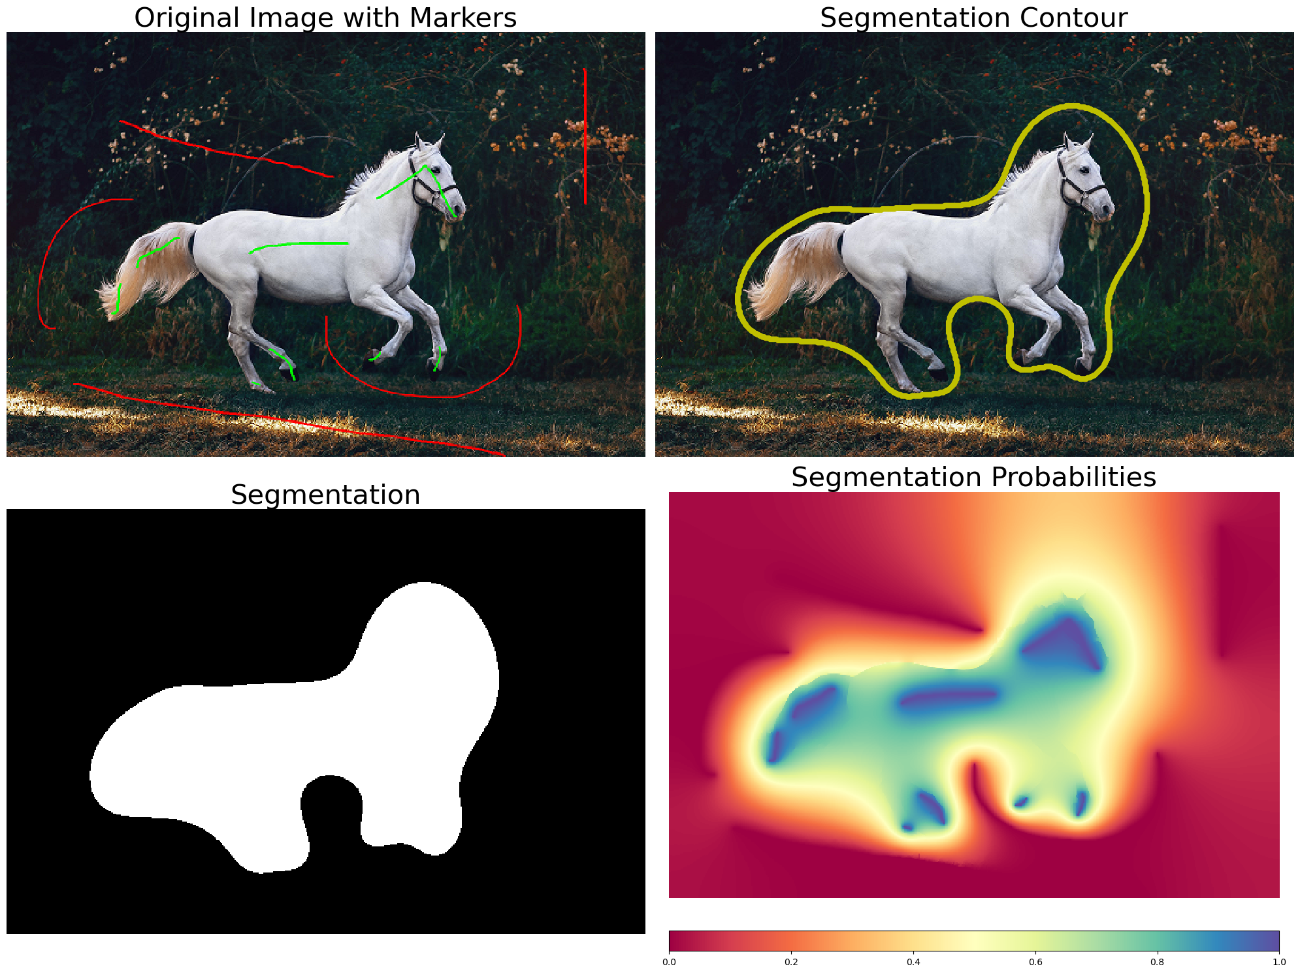  
**Figure 3.18**: Random walk segmentation with scikit-image

### **Fast marching segmentation with SimpleITK**

Fast marching image segmentation is a technique used in image processing and computer vision to segment structures or regions of interest in an image. It is based on the **Fast Marching Method** (**FMM**), which is a numerical technique for solving the Eikonal equation. The Eikonal equation describes the evolution of a front or wavefront in a way that is dependent on the local speed at each point. Mathematically, the Eikonal equation is given by:

$$∣∇T∣=F$$

Where $T$ is the arrival time (the time it takes for the front to reach a certain point), $∣∇T∣$ is the magnitude of the gradient of $T$ and $F$ is the speed function.

In the context of image segmentation using the FMM, the speed function $F$ represents the likelihood or confidence of a pixel belonging to a particular segment or region. It guides the evolution of the front, with regions of higher speed being reached earlier by the front. FMM evolves a front through the image, assigning labels to pixels based on the information obtained from the speed function.

Now, you will learn how to apply a fast marching segmentation on an image, using SimpleITK’s implementation of the algorithm.

The following are the steps you need to follow:

* Let us start by importing the required libraries and defining the parameter values for the functions to be used, using the following code snippet:

import SimpleITK as sitk  
import numpy as np  
import matplotlib.pylab as plt  
  
seed_position = (70, 170)  
sigma = 0.25  
alpha = -3.0  
beta = 10.0  
stopping_time = 100

* Read the input grayscale image using the ReadImage() function from SimpleITK.
* Let us first apply the filter function CurvatureAnisotropicDiffusionImageFilter() to the image, this filter is used for image smoothing or denoising. It applies to an anisotropic diffusion process that is guided by the local image structure, helping to preserve edges and boundaries while reducing noise. This filter is particularly useful for enhancing the visibility of structures in images. The method Execute() applies the filter to the input image to obtain the smoothed image smoothing_output, as shown in the following code snippet.
* Next, apply the filter function GradientMagnitudeRecursiveGaussianImageFilter() to the smoother image. This filter calculates the gradient magnitude of an image using a recursive Gaussian filter. This filter is commonly used to emphasize edges and highlight transitions between different intensity levels.
* Apply SigmoidImageFilter() to the gradient magnitude image for contrast adjustment or to enhance specific intensity range.
* Finally, apply FastMarchingImageFilter() function to the image. The FastMarchingImageFilter in SimpleITK is part of the toolkit’s segmentation module and is designed to perform image segmentation using the FMM. You need to provide the filter with the seed points (using the function SetTrialPoints()). These are the initial points from which the front will start to evolve. The filter will set these points as known and then iteratively update the arrival times around them.

You can set additional parameters, such as the stopping value (with the method SetStoppingValue()), determining when the front evolution should stop. You can subsequently apply the BinaryThresholdImageFilter() for thresholding the output image to create a binary image, as shown in the figure. Display all the images using the plot_image() function, as shown in the following code snippet:

def plot_image(img, title, img_type=np.float32):  
 im = sitk.GetArrayViewFromImage(img).astype(img_type)  
 im = im / im.max()  
 plt.imshow(im), plt.axis('off'), plt.title(title, size=20)  
  
input_image = sitk.ReadImage('images/Img_03_09.png', sitk.sitkFloat32)  
  
smoothing = sitk.CurvatureAnisotropicDiffusionImageFilter()  
smoothing.SetTimeStep(0.125)  
smoothing.SetNumberOfIterations(5)  
smoothing.SetConductanceParameter(9.0)  
smoothing_output = smoothing.Execute(input_image)  
  
gradient_magnitude = sitk.GradientMagnitudeRecursiveGaussianImageFilter()  
gradient_magnitude.SetSigma(sigma)  
gradient_magnitude_output = gradient_magnitude.Execute(smoothing_output)  
rescale = sitk.RescaleIntensityImageFilter()  
gradient_magnitude_output = rescale.Execute(gradient_magnitude_output)  
  
sigmoid = sitk.SigmoidImageFilter()  
sigmoid.SetOutputMinimum(0.0)  
sigmoid.SetOutputMaximum(255)  
sigmoid.SetAlpha(alpha)  
sigmoid.SetBeta(beta)  
sigmoid_output = sigmoid.Execute(gradient_magnitude_output)  
  
seed_value = 0  
fast_marching = sitk.FastMarchingImageFilter()  
trialPoint = (seed_position[0], seed_position[1], seed_value)  
fast_marching.AddTrialPoint(trialPoint)  
fast_marching.SetStoppingValue(stopping_time)  
fast_marching_output = fast_marching.Execute(sigmoid_output)  
  
thresholder = sitk.BinaryThresholdImageFilter()  
thresholder.SetLowerThreshold(0)  
thresholder.SetUpperThreshold(255)  
thresholder.SetOutsideValue(0)  
thresholder.SetInsideValue(1)  
output_image = thresholder.Execute(fast_marching_output)  
  
plt.figure(figsize=(20,15))  
plt.gray()  
plt.subplots_adjust(0,0,1,0.95,0.05,0.05)  
plt.subplot(231), plot_image(input_image, 'input')  
plt.subplot(232), plot_image(smoothing_output, 'smoothed')  
plt.subplot(233)  
plot_image(gradient_magnitude_output, 'gradient', np.uint8)  
plt.subplot(234), plot_image(sigmoid_output, 'sigmoid output')  
plt.subplot(235)  
plot_image(fast_marching_output, 'segmented (FastMarching)')  
plt.subplot(236), plot_image(output_image, 'segmentred (binarized)')  
plt.show()

If you run the aforementioned code snippet, you should obtain a figure as follows:

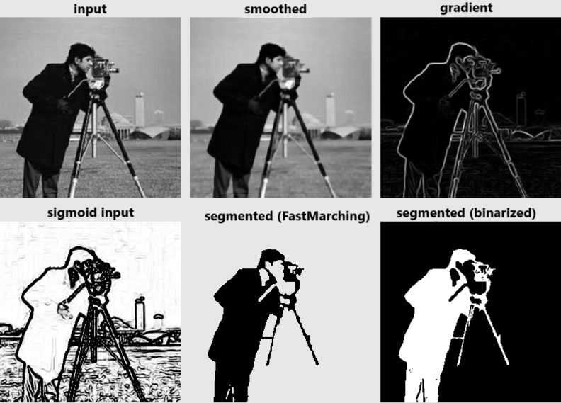  
**Figure 3.19**: Fast marching image segmentation with SimpleITK

Segmentation using SLIC/NCut with scikit-image

In this section, you will learn a few more segmentation algorithms, e.g., superpixel-based (**SLIC**) and **normalized cut** (**NCut**) based algorithms. We shall also demonstrate how to segment an image with these algorithms using skimage.segmentation and skimage.graph module functions, respectively.

### **SLIC segmentation**

SLIC is a super pixel segmentation algorithm used in computer vision and image processing. The goal of SLIC is to group pixels into perceptually meaningful and spatially compact regions called **super pixels**. Super pixels are essentially sets of contiguous pixels that share similar color and texture characteristics. SLIC is particularly useful for segmenting images into regions with similar color and texture. It is an extension of k-means clustering applied in a spatially localized manner.

The following is a brief overview of how SLIC segmentation works:

* **Initialization**: The algorithm starts by sampling a set of initial cluster centers, which are distributed regularly throughout the image. These initial cluster centers are determined based on a combination of image intensity and spatial proximity.
* **Assignment of pixels to super pixels**: Each pixel is then assigned to the nearest cluster center in a 5D space, consisting of color information (usually in the RGB or LAB color space) and spatial information (x, y coordinates). This assignment is done by considering both the color similarity and the spatial proximity of pixels to the cluster centers.
* **Update of cluster centers**: After the initial assignment, the cluster centers are updated by computing the mean color and position of all pixels assigned to each cluster. This step helps to refine the super pixel boundaries.
* **Iteration**: Steps 2 and 3 are iteratively repeated until convergence. The process converges when the cluster centers and assignments do not change significantly between iterations.
* **Compactness constraint**: SLIC includes a compactness constraint to ensure that the resulting super pixels are spatially compact. This is achieved by penalizing the distance between pixels and their assigned cluster centers based on the Euclidean distance in the 5D space.

The algorithm’s parameters include the number of desired super pixels and a weighting factor that controls the trade-off between color similarity and spatial proximity in the assignment step. By adjusting these parameters, users can control the size and regularity of the super pixels generated by SLIC. SLIC is known for its efficiency and effectiveness in producing visually meaningful super pixels.

### **Normalized cut**

Image segmentation with NCut is a technique that aims to partition an image into coherent regions based on the similarities between pixels. Normalized cut is a graph based method that considers both the similarities between pixels and the dissimilarities between different segments.

The objective function to be minimized in Ncut segmentation is defined to balance the desire for high similarity within clusters and low similarity between clusters. The goal is to find a partition of the graph (representing an image or data) that minimizes the normalized cut value.

The objective function for Ncut segmentation is typically expressed as follows:

$$NCut\left(A,B\right)=\frac{assoc\left(A,V\right)}{cut\left(A,B\right)}+\frac{assoc\left(B,V\right)}{cut\left(A,B\right)}$$

Where we have:

* $cut\left(A,B\right)$: The cut between clusters $A$ and $B$, representing the sum of weights of edges connecting nodes in $A$ to nodes in $B$.
* $assoc\left(A,V\right)$: The association of cluster $A$ with all vertices $V$, representing the sum of weights of edges connected to nodes in $A$.
* $V$: The set of all vertices in the graph.

The goal is to partition the graph into non-overlapping clusters $A$ and $B$ in such a way that the cut between them is minimized while considering the sizes of the clusters. The division by the association terms normalizes the cut values, making it independent of the sizes of the clusters.

The overall objective is to find clusters that have high internal similarity and low external similarity. The segmentation algorithm achieves this by solving an optimization problem that minimizes the normalized cut value. In practice, this is often achieved using spectral methods, where the eigenvectors of a certain matrix (usually the graph Laplacian) are used to represent the clusters. The algorithm seeks to find an optimal partition that satisfies these constraints while minimizing the normalized cut value, resulting in a meaningful segmentation of the image.

Now, let us demonstrate how an input image containing apples and oranges can be segmented using the scikit-image implementations of the aforementioned algorithms.

* We shall use the function segmentation.slic() to segment the input image using SLIC. The argument n_segments to the function determines the approximate number of segments to create, whereas compactness controls the balance between color similarity and spatial proximity in the segmentation.
* The function graph.rag_mean_color() function is part of the **Region Adjacency Graph** (**RAG**) analysis for image segmentation. The RAG is a graph representation where nodes correspond to image regions (super pixels or segments), and edges connect neighboring regions. The rag_mean_color() function specifically computes the mean color of each region in the RAG. The function returns a dictionary where keys are the region labels and values are the mean colors.
* Use the function graph.cut_normalized() to segment the image using NCut algorithm.
* Let us plot the original input image along with the segmented images, using the following code snippet, to obtain the following figure:

import skimage  
print(skimage.__version__)  
# 0.21.0  
  
from skimage import graph, segmentation, color  
from skimage.io import imread  
from matplotlib import pyplot as plt  
  
img = imread('images/Img_03_10.png')[...,:3]  
  
labels_slic = segmentation.slic(img, compactness=30, n_segments=400)  
out_slic = color.label2rgb(labels_slic, img, kind='avg')  
  
g = graph.rag_mean_color(img, labels_slic, mode='similarity')  
labels_ncut = graph.cut_normalized(labels_slic, g)  
out_ncut = color.label2rgb(labels_ncut, img, kind='avg')  
  
fig, ax = plt.subplots(nrows=2, ncols=2, sharex=True, sharey=True, \  
 figsize=(20, 15))  
ax[0,0].imshow(img), ax[0,0].set_title('Original image', size=20)   
ax[0,0].set_axis_off()  
ax[0,1].imshow(out_slic)  
ax[0,1].set_title('With SLIC superpixelation', size=20)   
ax[1,0].set_axis_off(), ax[1,0].imshow(out_ncut)  
ax[1,0].set_title('With Normalized-Cut', size=20)   
ax[0,1].set_axis_off(), ax[1,1].set_axis_off()  
plt.tight_layout()  
plt.show()

If you run the aforementioned code snippet, you should obtain a figure as follows:

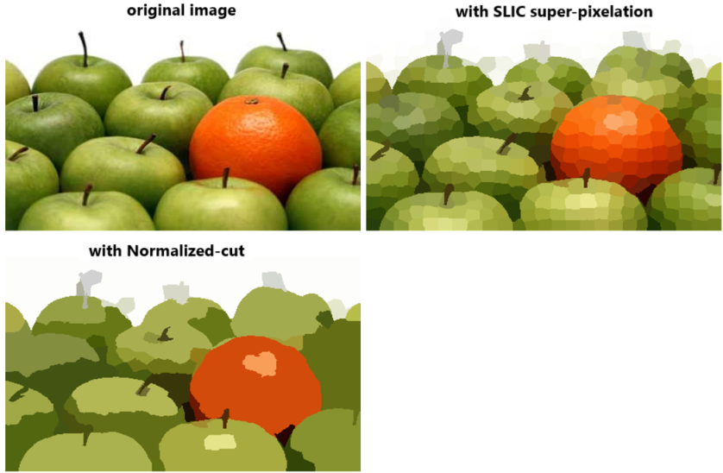

**Figure 3.20**: SLIC/NCut segmentation with scikit-image

RAG merging

RAG merging is a technique used in image segmentation, where the goal is to partition an image into meaningful regions. RAG merging involves the construction of a graph representation of an image, where nodes correspond to image regions, and edges represent the adjacency relationships between regions. The merging process is then applied to iteratively combine similar regions based on certain criteria.

The following is a basic outline of the steps involved in RAG merging:

* **Region growing**: Start with an initial over-segmentation of the image. This can be achieved using techniques like region growing or super pixel algorithms. Assign a unique label to each pixel or region.
* **Construct region adjacency graph**: Create a graph where each node corresponds to a region and edges connect adjacent regions. The weight of the edges can be defined based on a similarity metric between regions. This metric can consider color, texture, or other features.
* **Iterative merging**: Iterate through the edges of the RAG and merge regions that meet certain criteria. The merging criteria can be defined based on the similarity metric and a threshold. For example, merge adjacent regions if their color similarity is above a certain threshold.
* **Update RAG**: After merging, update the RAG by removing the edges between the merged regions and adding new edges to the merged region.
* **Repeat merging**: Repeat the merging process until no more merging is possible or until a predefined condition is met.

The following code snippet uses the function graph.cut_threshold() to combine regions separated by weight less than threshold (e.g., $50$ in the following code snippet). Given an image’s labels and its RAG, the function outputs new labels by combining regions whose nodes are separated by a weight less than the given threshold, as shown in the following code snippet:

img = io.imread('images/Img_03_11.png')[...,:3]  
  
labels_slic = segmentation.slic(img, compactness=30, n_segments=400)  
out_slic = color.label2rgb(labels_slic, img, kind='avg')  
  
g = graph.rag_mean_color(img, labels_slic)  
labels_rag = graph.cut_threshold(labels_slic, g, 50)  
out_rag = color.label2rgb(labels2, img, kind='avg')  
  
fig, ax = plt.subplots(nrows=2, ncols=2, sharex=True, sharey=True, \  
 figsize=(15, 12))  
fig.subplots_adjust(0,0,1,0.95,0.05,0.05)  
ax = ax.ravel()  
ax[0].imshow(img), ax[0].set_title('Original image', size=20)  
ax[1].imshow(segmentation.mark_boundaries(img, labels_slic,color=(0,0,0))) ax[1].set_title('With SLIC (boundaries marked)', size=20)  
ax[2].imshow(out_slic), ax[2].set_title('With SLIC', size=20)  
ax[3].imshow(segmentation.mark_boundaries(out_rag, labels_rag, \  
 color=(0,0,0)))  
ax[3].set_title('With SLIC + RAG merging', size=20)  
  
for a in ax:  
 a.axis('off')  
  
plt.show()

If you run the aforementioned code snippet, you should obtain a figure as follows:

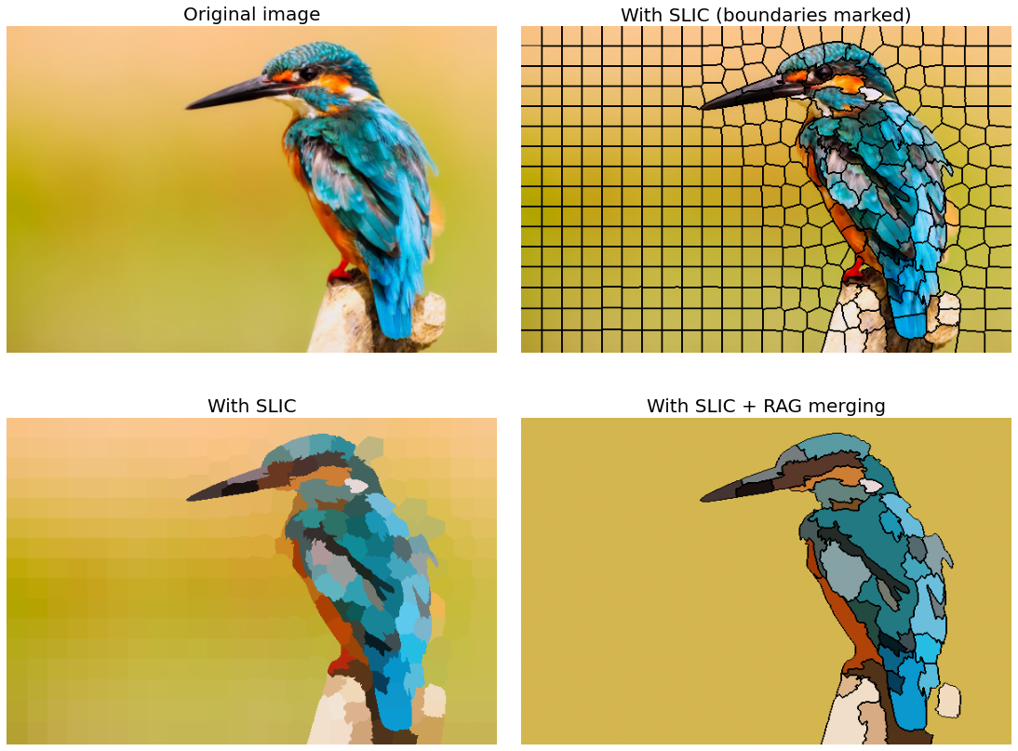

**Figure 3.21**: SLIC segmentation/RAG merging with scikit-image

Conclusion

In this chapter, we discussed a diverse array of image segmentation techniques and enhancement methods, exploring the intricacies of image processing. We have already seen edge detection algorithms such as Canny and LoG, these algorithms can be used for edge-based segmentation. Our primarily focus was on the region-based and machine learning-based segmentation techniques.

We understood the foundational concepts of gray level and bitplane slicing, shedding light on the significance of intensity levels within an image. Gray level slicing emerged as a powerful tool, particularly when applied to regions of interest for contrast enhancement.

Moving forward, we discussed image binarization, employing thresholding techniques with python libraries scikit-image, SimpleITK, and OpenCV-Python. Global and local thresholding methods were scrutinized, alongside advanced approaches such as max-entropy and adaptive thresholding. The chapter further covered a comprehensive exploration of segmentation techniques, including Mahalanobis distance clustering, k-means vs. spectral clustering, Meanshift segmentation, watershed segmentation, GrabCut interactive segmentation, RandomWalk segmentation, and fast marching image segmentation.

Our journey into segmentation continued with SLIC, normalized cut algorithms, and RAG merging. The diverse spectrum of techniques covered in this chapter provides readers with a comprehensive toolkit for image segmentation and enhancement, paving the way for innovative applications across various domains.

In the next chapter, we will understand a few advanced applications of deep learning models, introducing panoptic segmentation with Detectron2, background manipulation using DeeplabV3, and outlier detection employing autoencoder with H2O.

Questions

1. Use the threshold_local() function from skimage.filters module to obtain a local binary thresholded image (based on local pixel neighborhood) using a few different algorithms (e.g., mean, median, niblack, etc.) with camerman input image from skimage.data. You should obtain a figure like the following one (with block size 25, e.g.):

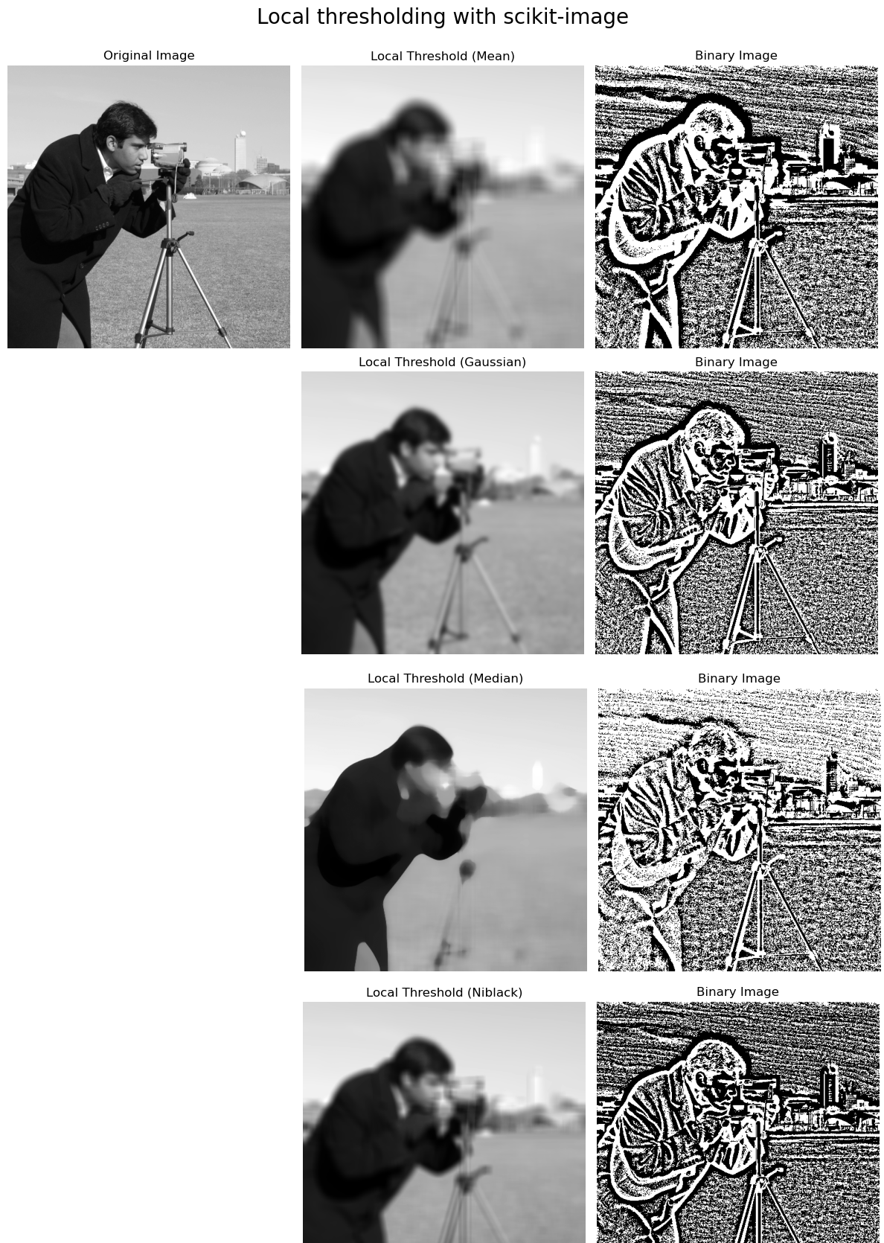

**Figure 3.22**: Local thresholding with scikit-image

Vary the block size to see the impact on the output binary image obtained.

1. **Segmentation using active contours with** SimpleITK: Active Contour Models, also known as snakes, are a popular method for image segmentation. The basic idea is to evolve a curve within an image to find boundaries that separate different regions of interest. Use the function GeodesicActiveContourLevelSetImageFilter() from SimpleITK to implement active contour. For example, with the following input rose image you should obtain a segmented output like the following figure:

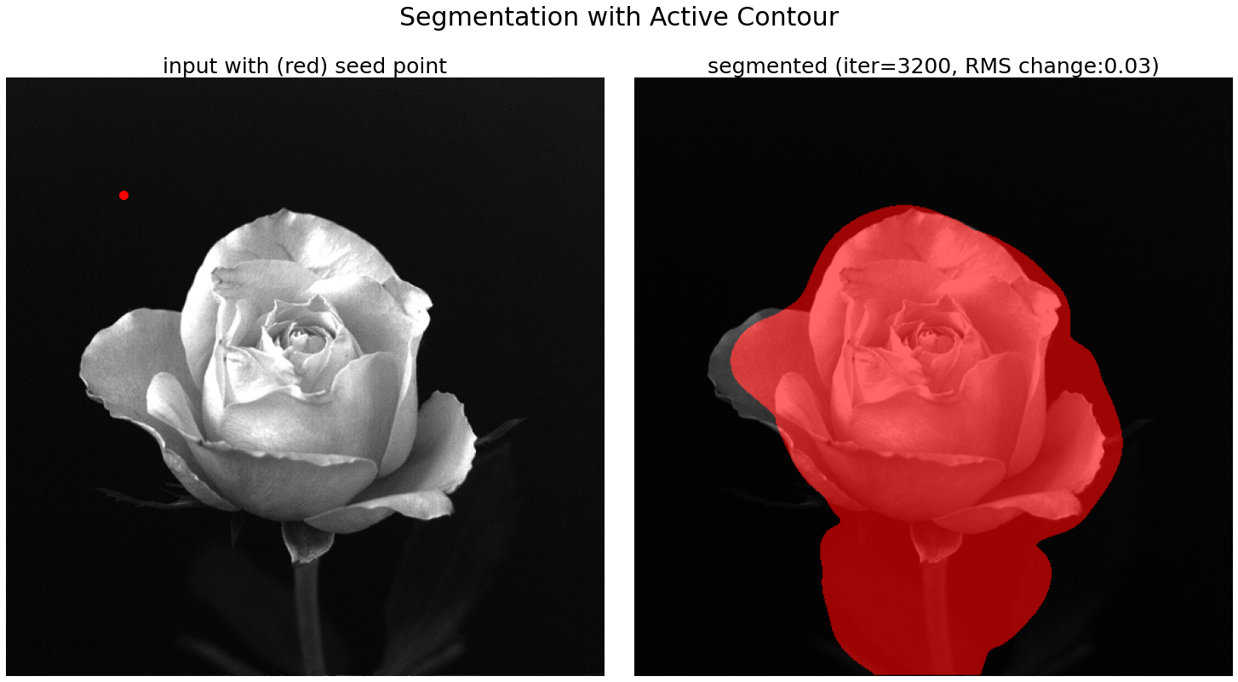  
**Figure 3.23**: Segmentation with active contour

### **Key terms**

Autoencoder, Meanshift, watershed, active contour, thresholding, Mahalanobis distance, GMM

References

1. <https://www.csd.uoc.gr/~tziritas/papers/segmentSpringer.pdf>
2. <https://www.iro.umontreal.ca/~mignotte/IFT6150/Articles/SLIC_Superpixels.pdf>
3. <https://dl.acm.org/doi/pdf/10.1145/1015706.1015720>
4. <https://people.eecs.berkeley.edu/~malik/papers/SM-ncut.pdf>
5. <http://vision.cse.psu.edu/people/chenpingY/paper/grady2006random.pdf>
6. <https://arxiv.org/pdf/1706.05587v3.pdf>
7. <https://www.youtube.com/watch?v=_HMyj_BIMoI>
8. <https://www.youtube.com/watch?v=DIODZIwwTK8>
9. <https://www.youtube.com/watch?v=seJ2jFvVGis>
10. <https://www.youtube.com/watch?v=PdAXkJObKGA>